AgriDivision: Agricultural Mapping System

with Demand Forecasting and Allocation

An Undergraduate Thesis

Presented to the Faculty of the

College of Information and Communications Technology

West Visayas State University

La Paz, Iloilo City

In Partial Fulfillment

Of the Requirements for the Degree

Bachelor of Science in Information Systems

Agustin, Andrea Joane J.

Fantilaga, Bryan Kyle E.

Monreal, Charles Agustin C.

Sanchez, Adrianne Blu T.

Trinidad, Royce Emmanuel A.

Approval Sheet

AgriDivision: Agricultural Mapping System with Demand Forecasting and Allocation

An Undergraduate Thesis for the Degree

Bachelor of Science in

Information Systems

By

Andrea Joane J. Agustin

Bryan Kyle E. Fantilaga

Charles Agustin C. Monreal

Adrianne Blu T. Sanchez

|  |  |  |
| --- | --- | --- |
| Dr. Ma. Beth S. Concepcion |  | Dr. Regin A. Cabacas |
| Panel |  | Panel |
| Dr. Erwin D. Osorio |  | Camille A. Sevillena |
| Panel |  | Panel |
| Nikie Jo E. Deocampo |  | Shem Durst Elijah B. Sandig |
| Panel |  | Adviser |

Royce Emmanuel A. Trinidad

Concurred:

Dr. Regin A. Cabacas Dr. Ma. Beth S. Concepcion

Chair, Division of IS Dean

June 2024

Acknowledgments

The researchers would like to express their deepest appreciation to the following persons, who in one way or another have made this work possible:

First and foremost, to our Almighty God and Savior for guiding and providing the researchers knowledge, determination, strength, patience, and wisdom in pursuing this study;

To the researchers’ families and loved ones, who gave their full support and for inspiring and keeping them motivated all throughout this study;

To Prof. Shem Durst Elijah B. Sandig, thesis adviser, for all the advice, encouragement, corrections, motivations, guidance, patience, time that he shared, and continuous support to the researchers;

To Dr. Ma. Beth S. Concepcion, CICT Dean, for allotting her time and giving advice, motivations, encouragement, and continuous support to the researchers;

To Dr. Regin A. Cabacas, for sharing his expertise and skills which helped the researchers;

To Engr. Jose Albert A. Barrogo, Regional Executive Director of Department of Agriculture Region 6, for accommodating the researchers for an interview and for sharing his time and expertise in providing information to come up with this study;

To Ms. Nelida C. Amolar, Officer-in-Charge of Philippine Statistics Authority Region 6, for her willingness to be interviewed and for sharing her valuable insights and knowledge that greatly contributed to this study;

To Mr. Joel P. Solis, Division Chief II of Philippine Coconut, for offering his time and effort to be interviewed and provide knowledgeable information to the researchers;

To the Farmers and Barangay Technicians, who were interviewed, and consulted, and also for the accommodation and for sharing information and insights to the researchers to come up with this study;

To the CICT Thesis Panels, for the insights, recommendations, critiques, knowledge, expertise, and values imparted to the researchers;

To the CICT Faculty and staff, for the support and wisdom;

And, to West Visayas State University, for shaping and for betterment to be a good role model and citizen.

The accomplishment of this study would not be possible without your help. To those who contributed to the researcher, a heartfelt gratitude.

Agustin, Andrea Joane J.

Fantilaga, Bryan Kyle E.

Monreal, Charles Agustin C.

Sanchez, Adrianne Blu T.

Trinidad, Royce Emmanuel A.

June 2024

Agustin, Andrea Joane J; Fantilaga, Bryan Kyle E.; Monreal, Charles Agustin C.; Sanchez, Adrianne Blu T.; Trinidad, Royce Emmanuel A. “AgriDivision: Agricultural Mapping System with Demand Forecasting and Allocation”. Unpublished Undergraduate Thesis, Bachelor of Science in Information Systems, West Visayas State University, Iloilo City, Philippines, June 2024.

Abstract

This study delves into the intricate dynamics of supply chain management within the Philippine agricultural sector, highlighting the critical roles of raw materials, crop demand forecasting, and allocation in driving sustainable economic growth. Additionally, it addresses challenges faced by the supply chain, advocating for comprehensive solutions including infrastructure modernization, regulatory reforms, and technology adoption. Emphasizing collaborative efforts among government agencies, industry stakeholders, and technology providers, the study aims to optimize crop demand forecasting and allocation processes, ultimately fostering greater efficiency, resilience, and global competitiveness in the Philippine agricultural landscape.

This study presents a web-based system that has a marketplace platform that connects farmers, business owners, and government sectors. The system also consolidates information on the prices of corn, coffee, and coconut in the market for monitoring. The target users of the system are farmers and business owners. The system was evaluated in terms of its functional suitability, performance efficiency, compatibility, usability, reliability, security, maintainability, and portability in performing market on Department of Agriculture and Philippine Coconut Authority operations by intended users, field experts, and system developers.

|  |
| --- |
| Page |

Table of Contents

|  |  |
| --- | --- |
| Title Page | i |
| Approval Sheet | ii |
| Acknowledgment | iii |
| Abstract | vi |
| Table of Contents | viii |
| List of Figures | xi |
| List of Tables | xiii |
| List of Appendices | xiv |
| Chapter |  |
| I INTRODUCTION TO THE STUDY | 1 |
| Background of the Study | 1 |
| Theoretical Framework | 6 |
| Objectives of the Study | 12 |
| Significance of the Study | 14 |
| Definition of Terms | 16 |
| Delimitation of the Study | 20 |
| II   REVIEW OF RELATED STUDIES | 22 |
| Reviews of Existing and Related Systems | 22 |
| III  RESEARCH DESIGN AND METHODOLOGY | 35 |
| Description of Proposed System | 35 |
| Methods and Proposed Enhancement  Components and Designs  System Architecture  Database Design  Process Design  System Development Life Cycle  IV RESULTS AND DISCUSSION  Proposed System  Implementation  Screenshots of the System  Result Interpretation and Analysis  System Evaluation Results  V   SUMMARY, CONCLUSIONS, AND RECOMMENDATIONS  Summary of the Proposed System and  Research Design  Summary of Findings  Conclusion  Recommendation  References  Appendices | 37  39  39  42  51  63  66  66  67  71  76  79  82  82  88  90  92  94  100 |
|  |  |
|  |  |
|  |  |
|  |  |

List of Figures

|  |  |  |
| --- | --- | --- |
| Figure | |  |
| 1 | System Architecture | 39 |
| 2 | Entity Relationship Diagram | 40 |
| 3  4 | Context Diagram  Level 0 Diagram | 47  48 |
| 5 | Use Case Diagram | 50 |
| 6 | Flowchart of the System for the Admin | 52 |
| 7 | Flowchart of the System for the Municipal Agriculturist | 53 |
| 8 | Flowchart of the System for the Barangay Technician | 54 |
| 9 | Flowchart of the System for the Farmer | 55 |
| 10 | Flowchart of the System for the Business Owner | 56 |
| 11 | System Development Life Cycle | 57 |
| 12 | Login Feature | 65 |
| 13 | Create Account Feature | 65 |
| 14 | Dashboard | 66 |
| 15 | Mapping Feature | 67 |
| 16 | Marketplace Feature | 67 |
| 17 | Register Farmer Feature | 68 |
| 18 | Register Barangay Technician | 68 |
| 19 | Register Municipal Agriculturist | 69 |

List of Tables

|  |  |
| --- | --- |
| Table | Page |
| 1   Evaluation Results for the Proposed System | 74 |

List of Appendices

Appendix                                        Page

|  |  |
| --- | --- |
| A   Letter Request to the Adviser | 96 |
| B   Letter of Request to the Editor | 97 |
| C   Letter to Conduct Interview | 98 |
| D   Gantt Chart | 104 |
| E   Data Dictionary | 105 |
| F   Entity - Relationship Diagram | 121 |
| G Sample Program Codes | 123 |
| H ISO 25010 Software Quality Standards Form | 125 |
| I Disclaimer | 134 |

CHAPTER 1 INTRODUCTION TO THE STUDY

Background of the Study and Theoretical Framework

Agro-processing refers to the range of technical and economic activities involved in preserving and handling agricultural products, making them suitable for use as food, feed, fiber, fuel, or industrial raw materials. This industry covers all steps from harvest to delivering the product to end users in the desired form, packaging, quantity, quality, and price. Agricultural mapping involves the use of technologies like remote sensing, GIS, GPS, and drones to collect and analyze spatial and temporal data about agricultural elements such as soil types, crop health, and water availability. This technology is crucial for implementing precision agriculture, optimizing resource management, and enhancing risk management, thus leading to better crop yields and cost savings (Agricultural Marketing : Agroprocessing (2008). It also aids in land use planning, ensuring sustainable agricultural practices, and assists in market and supply chain optimization. The availability of detailed and accurate maps helps farmers make informed decisions, enhancing overall agricultural efficiency and productivity. Raw materials are materials or substances used in the primary production or manufacturing of goods (Banton, 2023). According to McKinsey (2022), a supply chain includes all the raw materials and parts that are made into a product and distributed up the chain for manufacture and sale. The Supply Chain encompasses not only the producer and its suppliers, but also transporters, warehouses, retailers, and even customers depending on the logistics of the streams. In a more comprehensive sense, supply chains comprise new product development, marketing, operations, distribution, finance, and customer service.

Based on the research of Dacuycuy, C., and Serafica, R.,(2018) entitled “Harnessing the Potential of the Philippines’ Agricultural Sector: An Assessment using the Product Space”, developing the agro-processing industry appears to be a good strategy if the country is to harness the potential of the agricultural sector to contribute to sustainable economic growth and decent employment.

According to Diezhandino (2022), demand forecasting helps reduce risks and make efficient financial decisions that impact profit margins, cash flow, allocation of resources, opportunities for expansion, inventory accounting, operating costs, staffing, and overall spend. All strategic and operational plans are formulated around forecasting demand.

Without demand, there is no business. And without a thorough understanding of demand, businesses aren’t capable of making the right decisions about marketing spend, production, staffing, and more (Hand, 2022). Although demand forecast accuracy can never reach 100%, there are measures one can implement to enhance production lead times, improve operational efficiencies, reduce costs, introduce new products, and enhance the overall customer experience.

The Philippine Statistics Authority (PSA) adopts a structured and comprehensive approach to gather vital data on the agricultural sector through surveys, censuses, and collaborative efforts with other agencies (Philippine Statistics Authority, 2022). This method involves meticulous planning, intricate survey design, and the use of representative sampling techniques. The Philippine Statistics Authority (PSA) gathers crucial agricultural data using surveys, censuses, and collaborations with other agencies. Trained enumerators collect field data through interviews and observations, ensuring comprehensive coverage. PSA's thorough processing and analysis produce detailed reports that inform decision-making and drive improvements in the agricultural sector.

 The Department of Agriculture has embraced a methodical approach to data collection, harnessing surveys, on-field data gathering, and cutting-edge technology such as mobile apps and GPS for enhanced efficiency and accuracy (Department of Agriculture, 2023). This gathered data is meticulously stored within a centralized database, bolstered by stringent measures to safeguard data security and ensure compliance with privacy regulations. These efforts facilitate seamless updates and empower well-informed decision-making processes.

 In the Philippines, the supply chain for raw agricultural materials faces significant obstacles, such as outdated infrastructure, complex regulations, and limited adoption of technology. These challenges lead to inefficiencies, delays, and increased expenses for farmers and agribusinesses, hampering their productivity and economic sustainability. (Department of Agriculture, 2018).

These challenges have significant implications for the competitiveness of the Philippine agricultural industry, as it struggles to meet the demands of customers and compete with other countries in the global market. Addressing these issues requires a comprehensive approach that involves investments in modernizing infrastructure, simplifying regulations, and adopting technology to improve supply chain management for raw agricultural materials.

Theoretical Framework

The successful construct of demand forecasting is described in Forecasting: theory and practice (Petropoulos et al., 2022), which was chosen due to its strength in validity and reliability in various investigations through continuous validation. This study is made up of mapping, forecasting, and allocation theories and practices in terms of demand forecasting and data collection that strengthens this study. It is also a collection of success measures linked to general information system ideas and its three quality aspects; information, system, and service.

For mapping, according to Dumanski et al.(1987), when land uses were weighted by economic investment, the link strengthened, indicating that capital investments in agriculture are undertaken to maximize the production environment as well as overcome limits. In all locations, the association between agricultural land uses and physical land characteristics is statistically significant, showing that considerable agricultural adjustment has occurred. Some land use categories have very particular land needs, whilst others may withstand a wide range of circumstances. The degree of correlation or adjustment varies depending on the land use type (cropping system) and the nature of the land parameters taken into account. The role of "spatial interaction" implies socioeconomic land use adjustment, but its influence was always less than that of "soil association," which has implications for soil inventory projects and could result in significant operational cost savings if properly implemented. The results show that information theory can be used in soil science to investigate multifactorial, holistic systems, particularly those with nominal variables, rather than the traditional statistical techniques used in this study to calculate a global correlation of all land uses against all physical land factors.

For forecasting, the theory of forecasting is predicated on the idea that predictions about the future may be made using knowledge from the past and present. These are concepts that are able to find patterns in the previous values and effectively use them in the process of forecasting future values, especially for time series. Although it is not anticipated that future values will be predicted precisely, an expected value (also known as a point forecast), a prediction interval, a percentile, and an entire prediction distribution are among the numerous alternatives for a forecast of a single time series at a future time period. This collection of findings might be regarded as "the forecast" as a whole. Numerous other outcomes of a forecasting process are possible. The goal may be to predict an occurrence, such equipment breakdown, and time series might only have a little impact on the forecasting process. The finest forecasting techniques are those that have practical applications. By comprehending the key components of the issue, the theory may then be constructed. Theoretical findings can then influence better practice.

It is crucial to take into account the factors' nature and how they affect predicting. In univariate forecasting, predictions are created for a single time series utilizing data from the time series' past values, while in time series regression and multivariate forecasting, additional time series variables are used to produce the forecasts. In both univariate and multivariate forecasting, interventions, like special offers or extreme weather, may be possible. Relationships between variables and other forms of input may entail linear or nonlinear structures, such as the market penetration of a new technology. In the absence of a clear functional form, approaches like simulation or artificial neural networks may be used. To discover these linkages, theories from disciplines like economics, and meteorology might be crucial. Forecasting several variables at once is another definition of multivariate forecasting (e.g., econometric models).

Time series data or observed values exist in a wide variety of formats, which may restrict or dictate the forecasting approach that is used. In situations where judging approaches must be employed, such as the length of time it takes to construct a new airport, there may really be no historical observations at all for the topic of interest. The characteristics of the data can call for the creation of a novel forecasting approach. Every minute, hourly, weekly, monthly, and yearly are just a few examples of the many different ways that observations may occur. For instance, the energy business must anticipate demand loads at hourly intervals as well as

long-term demand for ten or more years in the future.

The data might consist of a single significant time series or billions of other time series. Numerous factors that influence one another are frequently included in economic analyses. Businesses frequently have time series that are significant at a variety of levels (e.g., stock holding unit, common components, or common size container), and as a result, these time series are organized in a hierarchy. The time series may have a few or many values that are zero, which would make it intermittent. There are literally many data form options. It may be necessary to pre-process the data before using a forecasting approach. There are fundamentals like examining correctness and missing values. The use of the forecasting technique may be preceded by other factors or the factors themselves may be included in the methods or models. Such an example is how seasonality is dealt with. While some forecasting methods address seasonality within the methods, others call for deseasonalized time series. Forecasts are produced by some government statistics organizations in order to extend time series into the future while estimating seasonal influences. (e.g., X-12 ARIMA), which makes it less clear when seasonality is taken into account relative to a forecasting method or model. (Petropoulos et al. 2022).

For Allocation, You et al. (2009) states that farmers plant specific crops for various reasons, such as satisfying subsistence food needs or catering to high-risk, high-reward export markets. Additionally, there are multiple ways of cultivating a given crop, influenced by factors like labor availability, animal power, seed quality, water supplementation, and agrochemical use. These distinct production systems can vary in crop yield and susceptibility to common threats or specific improvements. Hence, it is beneficial for researchers and policymakers to break down reported shares of crop production into major production system categories, at a minimum, to improve the usefulness of allocation results for development objectives. An ex-ante disaggregation of production into key production systems could improve the reliability of crop allocation by discriminating between the distinct location and yields of irrigated and rainfed production. This could help in predicting the production of basic foodstuffs in homestead plots. The authors were able to estimate crop production shares by production systems and perform the spatial allocation on the basis of the production system components, thanks to the availability of biophysical production potential maps, unpublished estimates of areas and yields, and other background data. The total national production was subdivided into up to four production systems for each crop, namely irrigated, high-input rainfed, low-input rainfed, and subsistence. Subsistence share of crop production was allocated based on population density, while irrigated and rainfed shares were allocated based on the different agro ecological conditions that best match the needs of each system. The crop-based production systems in Sub-Saharan Africa are dominated by low-input rainfed (including subsistence) production.

These studies are important for future researchers to be aware of the scope and limitations of the statements presented in this context. Future research should take these limitations into consideration and use a rigorous approach to overcome them.

Objectives of the Study

This study generally aims to develop a platform to monitor the demand and allocation by collecting data through result–oriented monitoring of agricultural raw materials in the province of Iloilo.

Specifically, it aims to:

* To develop a platform that generates aggregated demand for raw crop materials and allocates available resources accordingly.
* To develop a platform that establishes a marketplace, providing specific users with the capability to add product, purchase, and check the accessibility of available resources.
* To generate geographical visualization of raw crop materials and mapping of agri-players.
* To develop a module for demand forecasting of raw crop materials.
* To evaluate the performance of the system using ISO 25010 criteria.

Significance of the Study

The result of this study is beneficial to the following:

MSMEs.This study will aid Micro, Small, and Medium Enterprises (MSME) to help them know what will be the highest demand of raw crops in a particular area. This will also guide them to identify what part of the province is producing raw crop materials. This will also provide the MSMEs with information to determine the possible farms and industries as the raw crop production inside the province draws significant production from it.

Government Agencies. This study will aid government agencies to help them establish concurrent data gathering in a particular area. This study will also provide them with a system that can help in their monitoring of raw crop demand in agricultural sectors.

Farmers. Farmers may distinguish the root of their operation on their productions and be motivated to provide quality raw crop materials such as coconut, coffee, and corn in order to obtain the product in a fair procedure. They can conceptualize the demand of raw crops

and to maintain its production inside the province.

Future researchers. The concept in this study will be an open door to future researchers for more empirical studies towards a mapping system with demand forecasting. This will also be an insight that will serve as a reference to other researchers who intend on doing an in-depth study regarding this area.

Definition of Terms

The following terms were defined conceptually for better understanding and operational interpretation of the terms used in this study.

Agro-processing - refers to the manufacturing sub-sector that benefits from agriculture, fishery, and forestry-based industries' raw materials and intermediate goods. (Agroprocessing | CSIR, n.d.)

In this study, agro-processing is mentioned as the result when the raw crop materials are being collected. The raw crops are being processed as consumable commodities.

Allocation - giving someone their share of a total amount of something to utilize in a certain way:

* the allocation of resources/funds/time
* The funds were distributed by an organization that offers assistance and advocacy for disadvantaged children. (Johnson, 2005).

In this study, allocation refers to the process by which data from production predictions are combined to form a demand projection. This demand forecast is particularly useful for determining how to ration the raw crop that has been produced.

Demand - is the quantity of commodities that buyers are willing and able to purchase at various prices over a certain time period. The relationship between price and quantity desired is sometimes referred to as the demand curve. The fundamentals of demand, preferences and decisions, may be represented as functions of costs, chances, benefits, and other factors. (Team, 2024).

In this study, demand will be used in terms of forecasting methods when the data is collectively

gathered and defined.

Forecasting **-** described as a strategy that uses previous data as inputs to create informed predictions about the direction of future trends. Forecasts must frequently be altered since the future is unknown, and actual results might vary substantially. (Tuovila, 2022).

In this study, forecasting is one of the techniques that will be used on the system since it will be using estimates that are predictive in determining the future trends.

Inventory - is a detailed list of all the things in a place. Inventory is also the amount of goods a store has, or the value of them. (Kenton, 2024).

In this study, the researchers will use inventory such as storage platforms to keep the data gathered from a reliable source.

Micro, Small, Medium Enterprises (MSMEs)- these businesses are involved in the production, manufacture, and processing of goods and commodities. (International Labor Organization, 2023).

In this study, MSMEs are one of the users of the system in which they would be able to have the data in demand forecasting and allocation.

Delimitation of the Study

The study aims to develop a web-based application for agricultural mapping systems, demand forecasting, and allocation for its users. This web-based application uses three (3) main techniques:(1)Geographic Information System (GIS) for the mapping system,(2) Machine Learning in Demand Forecasting (Applications & Best practices) for demand forecasting, and (3) Optimization Algorithm for allocation. These techniques are being used in order to fulfill the efficiency of the system.

The study focuses on agricultural products but not limited to coffee, coconut, and corn. The target municipalities come from the whole province of Iloilo which is composed of several districts. The Department of Agriculture, and the Philippine Coconut Authority will be the admin of the system. In terms of showing the data in demand forecasting, the results will be based on the data gathered monthly. The data needed will be gathered by conducting an interview, giving out questionnaires to the Department of Agriculture, and Philippine Coconut Authority. The prediction of the forecast will be whether the demand for coconut, coffee, and corn is high or low. On the other hand, a mapping system will be provided depending on the demand and the location will be pinned accordingly.

CHAPTER 2 REVIEW OF RELATED SYSTEMS

## Review of Existing and Related Systems

3D Geological Mapping

According to Zhao et al. (2017), this system introduces a method for creating a detailed 3D model using 2D geological maps. The existing techniques for building a 3D geological model typically rely on field drilling or measured section data, which can be limited in availability, especially over large areas. However, 2D geological maps offer valuable information about the geometry, topology, and meaning of geological layers, making them useful for 3D modeling.

For this study, we used a mapping system wherein it provides users shortest route for allocation of products wherein users can track the land/farm which produces the crops, and provides feedback on the accuracy of demand forecasting, the effectiveness of resource allocation, and the performance of farmers and business owners.

Agricultural Systems

According to Debolini et al. (2013), the system features techniques for gathering, representing, and processing local spatial knowledge on farming and agricultural systems. It selects appropriate spatial scales to ensure accurate evaluation, considering the significant impact of scale selection on data collection and integration. However, the system faces challenges due to poor spatial integration of available data, limiting its ability to conduct place-based assessments of agricultural systems.

Manish et al.'s study (2021) highlights the development of a miniaturized mobile mapping system using unmanned ground vehicles (UGVs) for accurate and efficient data collection in agricultural fields. This system offers superior data collection capabilities compared to current agro phenotyping systems, particularly in under-canopy data collection, and provides georeferenced 2D and 3D products. The study also emphasizes the importance of the UGV's architecture, data quality assessment, and the ability to derive recorded data. With the continued advancement of technology, UGV-based mapping systems have the potential to revolutionize plant phenotyping and contribute to the improvement of agricultural productivity in the future.

ARIMA vs. LSTM: Forecasting Vegetable Prices in Colombo

According from the case study of Fonseka and Karunasena (2022), the ability to identify trends in vegetable prices is crucial in order to make informed decisions in both production and marketing. However, numerous factors such as seasonality, perishability, imbalanced supply-demand market, customer preferences, and the availability of raw materials make the vegetable market highly unstable and susceptible to rapid price fluctuations. To tackle this issue, the study implemented two models, namely Autoregressive Integrated Moving Average (ARIMA), and Long Short-Term Memory (LSTM). The ARIMA model is a statistical tool used for analyzing time series data by creating a linear equation that describes and predicts future values. It consists of three parts: the auto-regressive component that uses past data points, the integration component that accounts for overall trend in the data, and the moving average component that captures the effects of error or noise in the data. LSTMs are a type of RNNs that are specialized in learning long-term dependencies and were introduced in 1997 by Hochreiter & Schmidhuber. They are widely used and perform exceptionally well in various problem-solving scenarios. Unlike standard RNNs, LSTMs have a complex structure that enables them to remember information for extended periods, avoiding the long-term dependency problem. By combining these three parts, ARIMA model provides an accurate framework for forecasting future trends in time series data. Between 2009 and 2018, retail prices for cabbage, carrots, and green beans in Colombo were collected. Based on the decision criteria of RMSE and MAPE, the LSTM model was determined to be more successful than the ARIMA model in forecasting vegetable retail prices.

The study emphasizes how important it is to accurately predict vegetable prices in a market that is prone to volatility. It also demonstrates how the use of advanced machine learning techniques, such as LSTM, can improve prediction accuracy and provide the agriculture industry with useful information for making well-informed decisions. The study's findings are encouraging for Sri Lankan policymakers because they provide a way to build a more advanced and effective forecasting model, which can help stabilize prices, strengthen the market's resilience, and promote growth and sustainability.

Crop Prediction in Agricultural Systems

According to the study of Raja et al. (2022), as input variables to the machine learning algorithm, features are vital in determining the model's output. In the context of machine learning, features are the variables or attributes within a dataset that are used to make predictions or classifications. These features represent various aspects or characteristics of the data that the model can learn from. Features serve as a means of feeding pertinent data into the model, identifying patterns or relationships in the data, and affecting the precision of classifications or predictions.

In agriculture, the adoption of machine learning techniques alongside efficient feature selection methods has emerged as vital for precisely forecasting crop yield. Ensemble techniques, specifically, offer a notably superior means of enhancing prediction accuracy when compared to traditional classification methods. By incorporating these advanced methodologies, agriculture stands to benefit greatly, with the potential to markedly increase crop yield while mitigating the effects of swiftly changing environmental conditions.

Demand Forecasting and Allocation Systems in Agricultural Systems

According to Kilimci et al. (2019), one of the primary concerns of supply chains is demand forecasting, which aims to maximize inventory, minimize expenses, and boost sales, profit, and customer loyalty. To this end, historical data can be analyzed to improve demand forecasting through a variety of techniques, including deep learning models, machine learning techniques, and time series analysis. In this work, an intelligent demand forecasting system is developed. This enhanced model is predicated on the examination and interpretation of past data through the application of various forecasting techniques, such as deep learning models, support vector regression algorithms, and time series analysis approaches. The similarities and differences between these studies is that the study of Kilimci et al. (2019) uses multilayer feedforward artificial neural network (MLFANN) as a deep learning algorithm. In a feedforward neural network, data flows in successive layers of the network without any feedback, from the input nodes to the hidden nodes and finally to the output nodes while Agridivision uses a standard demand forecasting as its algorithm but with enhancement of mapping system and allocation.

Demand Forecasting for Smart Inventory Control  
 According to Benhamida et al. (2021), demand forecasting is the process of estimating the consumption of goods or services for future periods of time, and it is being used by many businesses to implement smart inventory management systems. This is due to the availability of data and the growing capabilities of data processing tools. Demand forecasting is critical for inventory control and supply chain management as it facilitates production and supply planning, ultimately leading to reduced delivery times and optimized supply chain decisions.

This paper extensively reviews demand forecasting methods for time-series data, highlighting their significance in enhancing operational efficiency and strategic decision-making within the supply chain. The validation of the proposed solution is carried out on Stock&Buy case study, an expanding online retail platform. The similarity of this study is the usage of demand forecasting in products, specifically crops. This is to facilitate the production of the crops needed by the business owners.

Integration of RAD in Agricultural Mapping

According to a case study by Chrismanto and Delima (2019), the application of information and communication technology (ICT) in agriculture can be one of the first steps toward increasing agricultural efficiency, effectiveness, and productivity, ultimately leading to the development of precision agriculture. Precision agriculture is stated to affect operational cost efficiency and boost the profitability of agricultural output utilizing ICT.

A web mapping system is one such system that assists in mapping land and areas. A web mapping technology is utilized in this case study to assist map farms held by farmer members of a farmer organization. For farm members and farmer organizations, the designed system maintains spatial data. The rapid application development (RAD) approach was used to create the online mapping system, which includes multiple iterative cycles. The concept was later applied to agricultural land. The system informs farmers on the status of the land they cultivate or own. Furthermore, the online mapping system can assess the state of the farmer group's accessible land as well as the requirement for agricultural production facilities and infrastructure. In addition, the web mapping system provides a dashboard with information that helps farmer groups manage land owned by each farmer who is a member of the group.

The key difference varies in their specific functionalities and focus. Chrismanto and Delima's study emphasizes the utilization of ICT, particularly in the context of precision agriculture, to increase efficiency and productivity in farming operations. On the other hand, the Agricultural Mapping System with Demand Forecasting and Allocation places a stronger emphasis on forecasting demand and allocating resources accordingly, suggesting a more comprehensive approach to agricultural management that goes beyond mapping alone.

Mapping of Agricultural Production Systems

According to the International Food Policy Research Institute (2017), The Agro-MAPS database was created primarily to fill critical gaps in the data coverage needed to conduct analyses related to soil degradation, food security, agricultural systems research, nutrient balance, and climate change impacts. In addition, the database now contains data on crop production, harvested area, and yield for each country over the year. Based on relative harvested area, the current web version of this database offers data for a selection of 20 crops of regional and worldwide relevance.

The Agro-MAPS database fills critical data gaps for analyzing soil degradation, food security, agricultural systems research, nutrient balance, and climate change impacts. It contains data on crop production, harvested area, and yield for each country over the year, with a current web version covering a subset of 20 important crops. For this study, the mapping is used to determine the location of the land with the crop harvested area in order for the business owners to locate the area to purchase the crops wanted.

Network Marketing of Agriculture in the "Internet+" Era

According to Gao (2020), in the context of China, where the adoption of internet-based marketing models for agricultural products is gaining momentum, this study explores the evolution and potential of "Internet +" agriculture. It starts by contextualizing the "Internet +" backdrop, illustrating its transformative effects on agricultural marketing. The integration of internet technology with agriculture has become a cornerstone for agricultural growth worldwide, particularly in industrialized nations. The importance of agricultural mapping systems in demand forecasting and allocation studies within this marketing ecosystem is one of the study's key points. These systems use data-driven methodologies to analyze consumer behavior, agricultural production, and demand trends. By incorporating these insights into marketing strategies, stakeholders can more efficiently allocate resources, streamline distribution channels, and effectively anticipate market demands.

In conclusion, This study highlights the need for a comprehensive approach to marketing models, emphasizing their interconnectedness in driving national agricultural product sales. The successful integration of internet technology with agriculture has greatly improved marketing strategies, as evidenced by its adoption in developed nations and the country's growing adoption of internet-based agricultural product marketing models. This system adds to the growing body of knowledge by putting forth a customized model for agricultural product network marketing in the nation. And by using Agridivision, both studies showed that both use an internet connection in order to work.

CHAPTER 3 RESEARCH DESIGN AND METHODOLOGY

Description of the Proposed System

This system aims to create an application that utilizes information gathered from farmers and business owners, including their latitude and longitude coordinates. Farmers and business owners both have important roles to play in this system. Farmers upload details about their commodities, such as type, quantity, and price, and business owners use the mapping feature to filter marketplace products according to preferred locations and crops. This gives farmers and business owners the ability to strategically locate the closest suppliers of desired crops in the market.

The administrative side will be handled by the Department of Agriculture and the Philippine Coconut Authority respectively. The admins are capable of monitoring the total production of the aggregated data of the raw crop materials gathered from the municipal agriculturists from each municipality which have been retrieved from barangay technicians.

Municipal agriculturists on the other hand are capable of inputting the data they have gathered from the farms that produce raw crop materials located in their municipality in which the aggregated data will then be shown in the administrative end.

Meanwhile, barangay technicians are capable of recording the data they have gathered from the farms that produce raw crop materials located in their barangay.

Furthermore, farmers are capable of monitoring their farm’s previous and current production rate according to their input.

Lastly, business owners are capable to see pinned locations of farms that produce raw crop materials, the estimated travel time towards the farm and the estimated kilometers to be traveled.

Overall, the study seeks to improve the efficiency of agricultural production and promote the growth of the agricultural sector in Iloilo.

Methods and Proposed Enhancements

Information will be collected from multiple origins such as the Internet, literature, archives, as well as from the Department of Agriculture's (DA) data on coffee and corn, from the Philippine Statistics Authority (PSA), and from the Philippine Coconut Authority (PCA) for the data on coconut and their associated research studies for this project. In addition, the researchers will solicit guidance and suggestions from qualified experts in the field.

The system has a marketplace feature which allows farmers to market their produce, input their crop harvest for the month, and input the number of crops in kilograms they are willing to sell. Whereas, business owners are capable to locate the nearest locations of farms that have the available resources, and be able to purchase it.

The system also has a mapping system wherein the users can locate the following: (1) farmers per municipality, (2) business owners, (3) barangay technicians, (4) municipal agriculturists.

The system also has a module feature for demand forecasting of raw crop materials for farmers and business owners to track the demand and supply of raw crop materials.

Components and Design

*System Architecture*

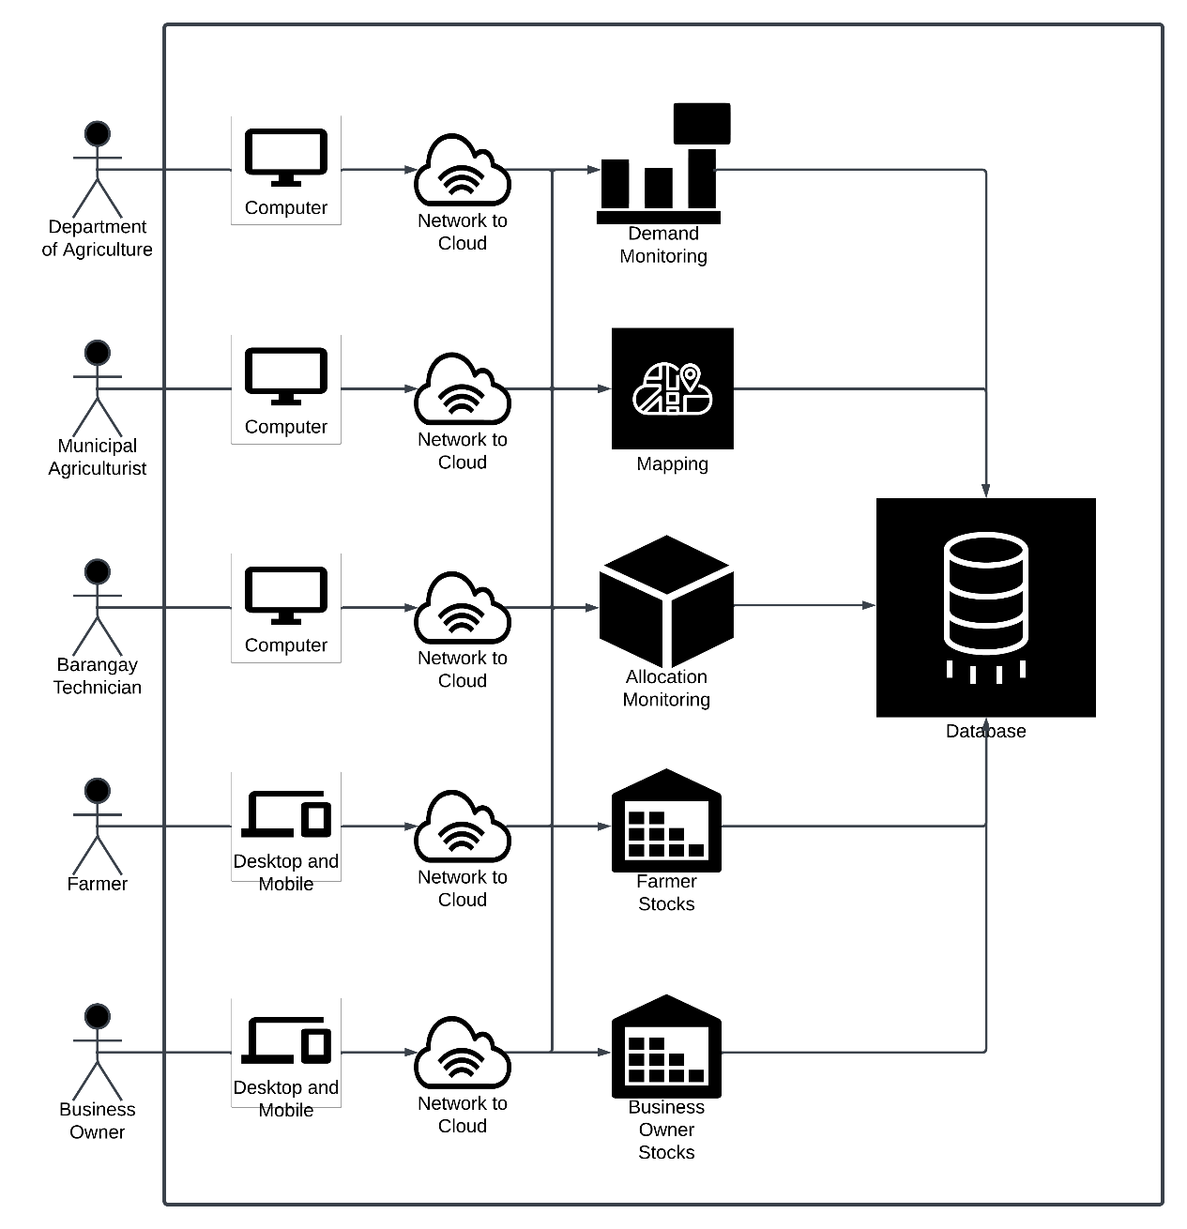

**Figure 1**. System Architecture of the System

The system architecture of the system consists of five actors namely; the Farmer, Business Owner, Municipal Agriculturist, Barangay Technician, and Admin. The system functionalities include mapping, demand forecasting, and accounts. On the administrative, municipal agriculturist, barangay technician sides, they are directly connected to the server and network which will enable them to access the allocation and demand monitoring.

On the farmer and business owners’ side, they are able to access the farmer stocks, and business owner stocks respectively. Enabling them to add their available resources which will be shown in the allocation and demand tables. Also, the location of farms and businesses will be accessed through mapping.

*Database Design*

*ERD*

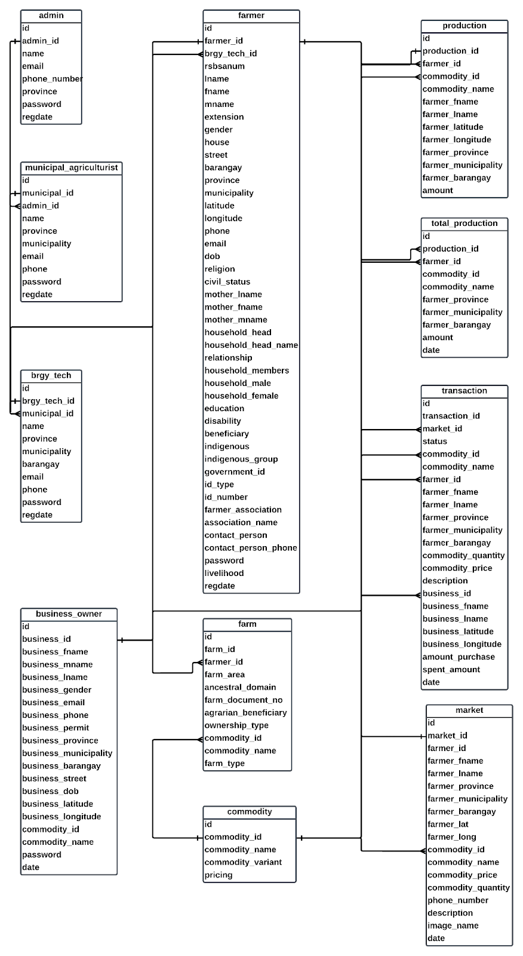

**Figure 2.** ERD of the System

The "AgriDivision" database consists of five main tables: "admin", "farmer", ”municipal agriculturist”, "business owner", “barangay technician”.

The “admin” database stores the following data: id, admin id, name, email, phone number, province, password, regdate.

The “municipal agriculturist” table stores the following data: id, municipal id, admin name, province, municipality, email, phone, password, regdate. The “barangay technician” table stores the following: id, brgy tech id, municipal id, name, province, municipality, barangay, email, phone, password, regdate.

The “farmer” table stores the following: id, farm id, brgy tech id, rsbsa num, lname, fname, mname, extension, gender, house, street, barangay, province, municipality, latitude, longitude, phone, email, dob, religion, civil status, mother lname, mother fname, mother mname, household head, household head name, relationship, household members, household male, household female, education, disability, beneficiary, indigenous, indigenous group, government id, id type, id number, farmer association, association name, contact person, contact person phone, password, livelihood, regdate.

The “business owner” table stores the following: id, business id, business fname, business mname, business lname, business gender, business email, business phone, business permit, business province, business municipality, business barangay, business street, business dob, business latitude, business longitude, commodity id, commodity name, password, date.

The ERD for the "AgriDivision” database would illustrate how these tables are related to each other and work together to support the system goals.

The database design outlines how the database is structured and describes the normalization of tables.

Admin

|  |  |  |  |
| --- | --- | --- | --- |
| id | admin_id | name | email |
| 123 | DA1 | John | john@gmail.com |

|  |  |  |  |
| --- | --- | --- | --- |
| phone_num | province | password | regdate |
| 09561895614 | Iloilo | Miagao | 12/21/2023 |

Barangay Technician

|  |  |  |  |
| --- | --- | --- | --- |
| id | brgy_tech_id | municipal_id | name |
| 123 | BT1 | MA1 | John |

|  |  |  |  |
| --- | --- | --- | --- |
| province | municipality | barangay | email |
| Iloilo | Miagao | Baybay Sur | johndoe@gmail.com |

|  |  |  |
| --- | --- | --- |
| phone | password | regdate |
| 09123456789 | JohnDoe01 | 12/21/2023 |

Business Owner Table

|  |  |  |  |
| --- | --- | --- | --- |
| id | business_id | business_fname | business_mname |
| 123 | B01 | John | Michael |

|  |  |  |  |
| --- | --- | --- | --- |
| business_lname | business_gender | business_email | business_phone |
| Doe | Male | johndoe@gmail.com | 09123456789 |

|  |  |  |  |
| --- | --- | --- | --- |
| business_permit | business_province | business_municipality | business_barangay |
| BP-2021-0000X-0 | Iloilo | Miagao | Baybay Sur |

|  |  |  |  |
| --- | --- | --- | --- |
| business_street | business_dob | business_latitude | business_longitude |
| Hinolan Street | 2/21/2023 | 10° 38' 26.4 | 122°14'6.3 |

|  |  |  |
| --- | --- | --- |
| commodity_id | password | date |
| CM1 | John01 | 12/21/2023 |

Commodity Name Table

|  |  |  |  |
| --- | --- | --- | --- |
| id | commodity_id | commodity_name | commodity_variant |
| 123 | CM1 | Corn | Dent |

|  |  |
| --- | --- |
| commodity_metric | pricing |
| Kilograms | 50 |

Farm Table

|  |  |  |  |
| --- | --- | --- | --- |
| id | farm_id | farmer_id | farm_area |
| 123 | F1 | FM1 | 100 |

|  |  |  |  |
| --- | --- | --- | --- |
| ancestral_domain | farm_document_no | agrarian_benefeciary | ownership_type |
| Yes | 40214 | Yes | Tenant |

|  |  |  |
| --- | --- | --- |
| commodity_id | commodity_name | farm_type |
| CM1 | Corn | Irrigated |

Farmer Data Table

|  |  |  |  |
| --- | --- | --- | --- |
| id | farm_id | farmer_id | brgy_tech_id |
| 123 | F1 | FM1 | BT1 |

|  |  |  |  |
| --- | --- | --- | --- |
| rsbsanum | lname | fname | mname |
| 12345678 | Doe | John | Michael |

|  |  |  |  |
| --- | --- | --- | --- |
| extension | gender | house | street |
| Jr | Male | 123 | Hinolan Street |

|  |  |  |  |
| --- | --- | --- | --- |
| barangay | province | municipality | latitude |
| Baybay Sur | Iloilo | Miagao | 10° 38' 26.4 |

|  |  |  |  |
| --- | --- | --- | --- |
| longitude | phone | email | dob |
| 122°14'6.3 | 09123456789 | johndoe@gmail.com | 12/21/2023 |

|  |  |  |  |
| --- | --- | --- | --- |
| religion | civil_status | mother_lname | mother_fname |
| Roman Catholic | Single | Doe | Jonna |

|  |  |  |  |
| --- | --- | --- | --- |
| mother_mname | household_head | household_head_name | relationship |
| Mitchel | Yes | John | Son |

|  |  |  |  |
| --- | --- | --- | --- |
| barangay | province | municipality | latitude |
| Baybay Sur | Iloilo | Miagao | 10° 38' 26.4 |

|  |  |  |  |
| --- | --- | --- | --- |
| household_members | household_male | household_female | education |
| 6 | 3 | 3 | Elementary |

|  |  |  |  |
| --- | --- | --- | --- |
| disability | benefeciary | indegenous | indegenous_group |
| No | No | Yes | Aeta |

|  |  |  |  |
| --- | --- | --- | --- |
| government_id | id_type | id_number | farmer_association |
| Yes | National ID | 6154-7645-6543-0979 | Yes |

|  |  |  |  |
| --- | --- | --- | --- |
| association_name | contact_person | contact_person_phone | password |
| Department of Agrarian Reform | Jonna | 09123456789 | Johndoe01 |

|  |  |
| --- | --- |
| livelihood | regdate |
| Farmer | J12/21/2023 |

Market Data Table

|  |  |  |  |
| --- | --- | --- | --- |
| id | market_id | farmer_id | farmer_fname |
| 123 | M1 | FM1 | John |

|  |  |  |  |
| --- | --- | --- | --- |
| farmer_lname | farmer_province | farmer_municipality | farmer_barangay |
| Doe | Iloilo | Miagao | Baybay Sur |

|  |  |  |  |
| --- | --- | --- | --- |
| farmer_lat | farmer_long | commodity_id | commodity_name |
| 0° 38'26.4 | 122°14'6.3 | CM1 | Corn |

|  |  |  |  |
| --- | --- | --- | --- |
| commodity_price | commodity_quantity | phone_number | description |
| 50 | 100 | 09123456789 | Dent Corn |

|  |  |
| --- | --- |
| image_name | date |
| Corn.jpeg | 12/21/2023 |

Municipal Agriculturist Data Table

|  |  |  |  |
| --- | --- | --- | --- |
| id | municipal_id | admin_id | name |
| 123 | MA1 | DA1 | John |

|  |  |  |  |
| --- | --- | --- | --- |
| province | municipality | barangay | email |
| Iloilo | Miagao | Baybay Sur | johndoe@gmail.com |

|  |  |  |
| --- | --- | --- |
| phone | password | regdate |
| 09123456789 | JohnDoe01 | 12/21/2023 |

Production Data Table

|  |  |  |  |
| --- | --- | --- | --- |
| id | production_id | farmer_id | commodity_id |
| 123 | P1 | FM1 | CM1 |

|  |  |
| --- | --- |
| commodity_name | amount |
| Corn | 100 |

Total Production Table

|  |  |  |  |
| --- | --- | --- | --- |
| id | production_id | farmer_id | commodity_id |
| 123 | TP1 | FM1 | CM1 |

|  |  |  |
| --- | --- | --- |
| commodity_name | amount | date |
| Corn | 100 | 12/21/2023 |

*Process Design*

**Figure 3.** Context Diagram of the Proposed System

**Figure 4.** Level 0 Diagram of the System

Figure 3 and 4 shows the Context Diagram and Level 0 diagram of the system respectively. The diagrams show the relevance of each data input from the actors namely: admin, farmer, business owner, barangay technician, municipal agriculturist.

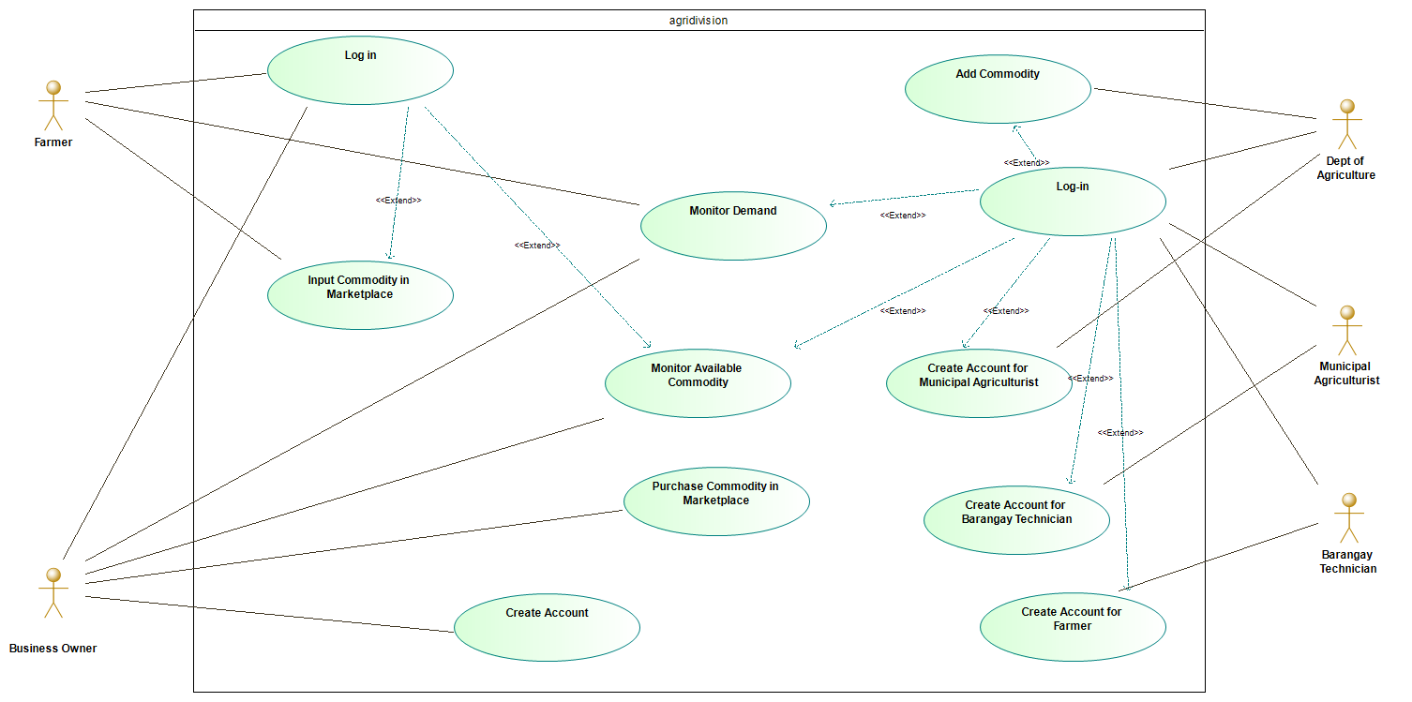

**Figure 5.** Use Case Diagram of the System

There are five actors involved in the system namely: Admin, Municipal Agriculturist, Barangay Technician, Business Owner, and Farmer. The admin has the capability to create the account of the municipal agriculturist, whereas the municipal agriculturist has the capability to create the account of the barangay technician which will be in charge of creating the farmer’s account. The system allows these actors to monitor the demand, supply and allocation of the available raw crop materials.

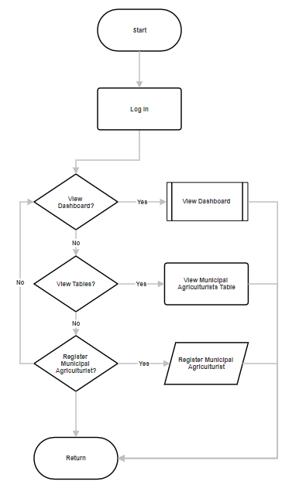

**Figure 6.** Flowchart of the System for the Admin

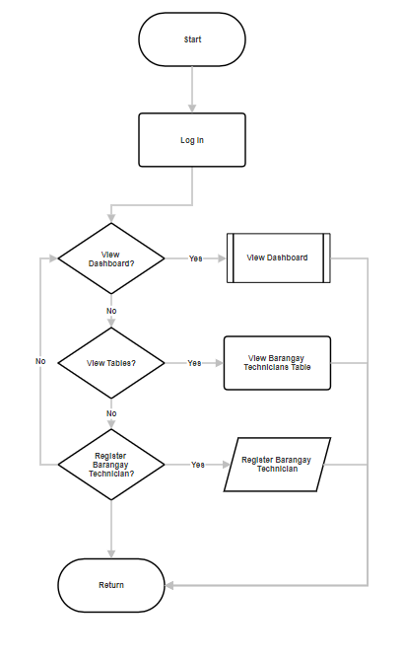

**Figure 7.** Flowchart of the System for the Municipal Agriculturist

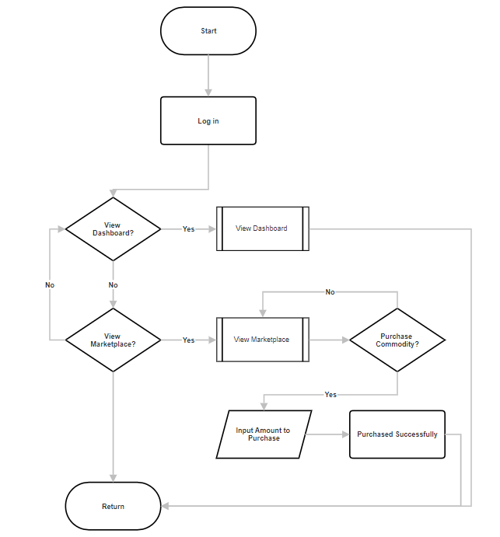

**Figure 8.** Flowchart of the System for the Barangay Technician

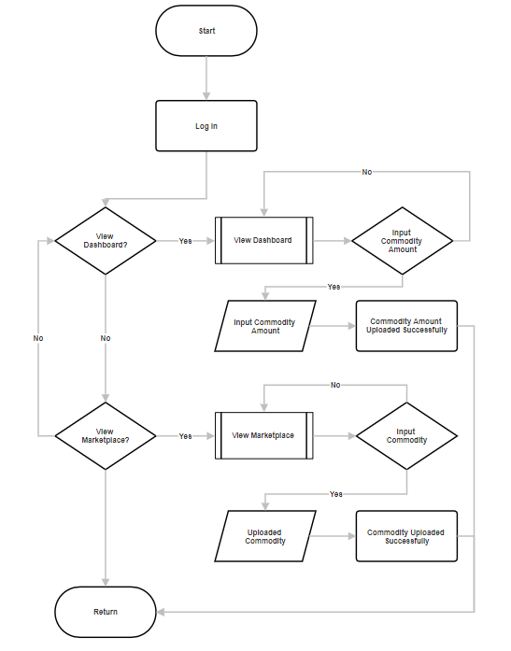

**Figure 9.** Flowchart of the System for the Farmer



**Figure 10.** Flowchart of the System for the Business Owner

Figures 6-10 shows the different processes of the system depending on what type of user is going to use the system.

*System Development Life Cycle*

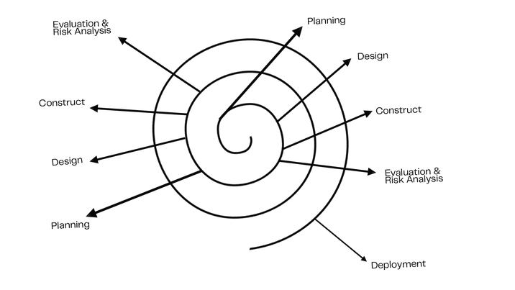

**Figure 11.** Spiral Model

The System Development Life Cycle to be utilized will be the Spiral Model. The Spiral Model is extensively utilized in the software industry since it corresponds to the mechanism by which any product naturally develops. The model is comprised of five phases, specifically;

Identification and Planning. During this process the researchers are to identify the government agencies (Department of Agriculture, and Philippine Coconut Authority), municipal agriculturists, barangay technicians, farmers, and business owners that will benefit the system. Also, the identification of what type of data to be gathered and where to gather it is also identified in this stage.

Design.This process involves the design stage of the system. After gathering the data needed (statistical and raw data) from the Department of Agriculture, and Philippine Coconut Authority, the designing process of the system is executed and the creation of the system mock-up is executed. The functionality and design of the system is also done at this stage.

Construct or Build.In this process the researchers are to start the construction of the system based on the mock-up created in the previous step, including the functionalities of the system, design, and creation of multiple accounts for the users; Admin, Farmers, Barangay Technicians, Agriculturists, and Business owners. It involves developing a web-based application using HTML for structure, with styling and design handled by CSS, and dynamic functionality implemented through JavaScript. The backend is powered by PHP and SQL, with XAMPP providing the local server environment. The project uses Visual Studio Code (VSCode) as the primary development platform and Bootstrap Studio Code for responsive design elements. Additionally, a Google Maps API is integrated to enhance location-based features, while a Moving Average algorithm is employed for data analysis or trend prediction within the application.

Evaluation and Risk Analysis. During this process the system is tested and evaluated according to the system’s needs by the researchers, and the selected admin of the system before deployment. The researchers are to identify the possible risks that the system may face.

Deployment. In this stage after evaluating and mitigating the risks in the system which is done by the admin and the researchers, the system is then deployed and distributed to the Department of Agriculture, Philippine Statistics Authority, Farmers, and Agriculturists.

CHAPTER 4 RESULTS AND DISCUSSION

Proposed System

The proposed system is a state of the art agricultural management platform designed to address the unique needs and challenges faced by farmers, business owners, barangay technicians, and municipal agriculturists to include key stakeholders such as the PCA (Philippine Coconut Authority) and the DA (Department of Agriculture). By leveraging the power of the technology, the system aims to streamline agricultural processes, enhance productivity and promote sustainable farming practices. Through a user-friendly interface, farmers will have access to a range of tools and features to effectively manage their crops, track their inventory and access valuable market insights.

Business owners, on the other hand, can utilize the system efficiently, manage their supply chains, establish partnerships with farmers, and gain real-time visibility into crop availability.

Municipal agriculturists and barangay technicians can leverage the system’s analytics capabilities to identify areas of improvement, monitor the impact of agricultural policies, and implement targeted interventions to support the local farming community.

The PCA (Philippine Coconut Authority) and the DA (Department of Agriculture) can leverage the system to monitor and support the farmers, providing vital resources, guidelines, and insights on the crops market trends.

Implementation

During the implementation stage, six parties are involved: the proponents (Department of Agriculture, and the Philippine Coconut Authority) and the users (Municipal Agriculturists, barangay technicians, farmers, and business owners. Testing and debugging processes will be carried out by the researchers to identify any errors during this stage.

The system is set to be turned over to the Department of Agriculture and the Philippine Coconut Authority once fully functional. The said departments will manage the system and will be responsible for distributing it to the users (Farmers, Municipal Agriculturists, barangay technicians, and Business owners).

Once deployed and turned over by the researchers, the proponents have the responsibility of system maintenance and repair. On the user's side, the proponents will provide instructions on the proper utilization of the web-based system and give them the ability to explore its features.

Technical Specifications

## To ensure the effective implementation and smooth operation of the system, it is crucial to meet specific requirements and adhere to certain specifications. The subsequent sections outline the necessary software, hardware, and user specifications.

Hardware Specifications

|  |  |
| --- | --- |
| Operating System | at least Windows 10 Pro N or latest versions of operating system |
| RAM | At least 8 GB RAM |
| Processor | Intel Core i5V-Pro |
| Disk Space | At least 6 GB Disk Space |

In order for the system to fully operate, it needs the following hardware specifications:

The system can be accessed on any device as long as there is an internet connection within the device’s vicinity. Though the system is web-based, it is advisable to use a computer or laptop for better view and access to the system’s features.

Software Specifications

The following are the software specifications of the system:

|  |  |
| --- | --- |
| Development Tools | Visual Studio Code version 4.0 and Bootstrap Studio version 4 |
| Mapping Tool | Google Maps Application Program Interface (API) |
| Network Requirement | Requires internet connectivity |
| Required Web Browsers | Google Chrome, Edge, Opera, Mozilla Firefox, Safari, etc |

User Specifications

The individuals who may utilize the system can be anyone with minimal to great knowledge towards technology and is computer literate. The users who have these qualities are needed in order for them to fully grasp the concept of the said system and work on it easily.

System Inputs and System Outputs

For the completion of the study, the system is bound to project an output that would start from requiring the user to sign in or create an account based on what type of user they are assigned to (admin, farmer, municipal agriculturist, barangay technicians, business owner), and input the information required.

Screenshots of the System

**Figure 12.** Login Feature

Figure 12 presents the Login feature of the system. The User is asked to input their email and password in order to access the system.

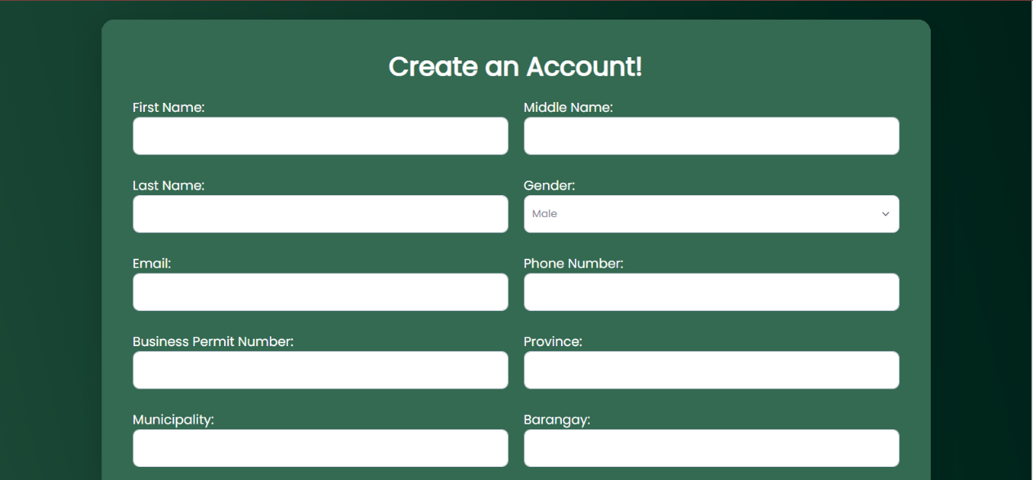

**Figure 13.** Create Account Feature

Figure 13 shows a feature on creating an account. The input should be the user’s personal information such as names, address, contacts, and other important information.

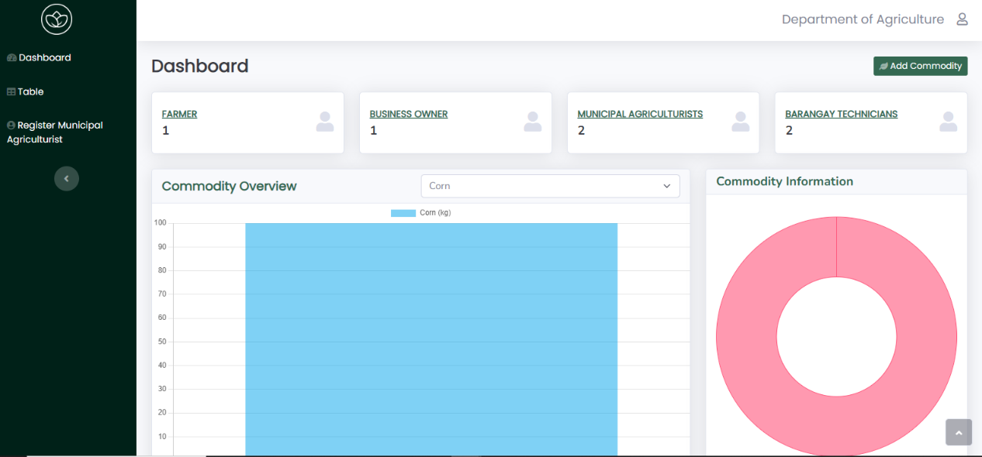

**Figure 14.** Dashboard

Figure 14 shows the Dashboard of the system which displays summaries of various data inputted by farmers and business owners.

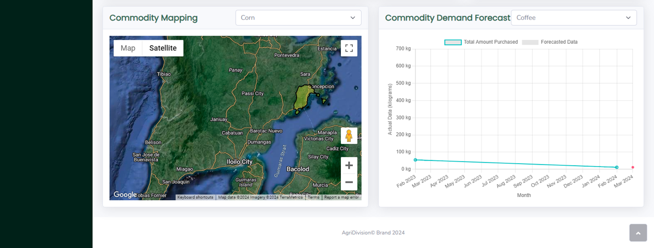

**Figure 15.** Mapping Feature

Figure 15 shows the mapping feature of the system. Showing amount(s) available in each municipality.

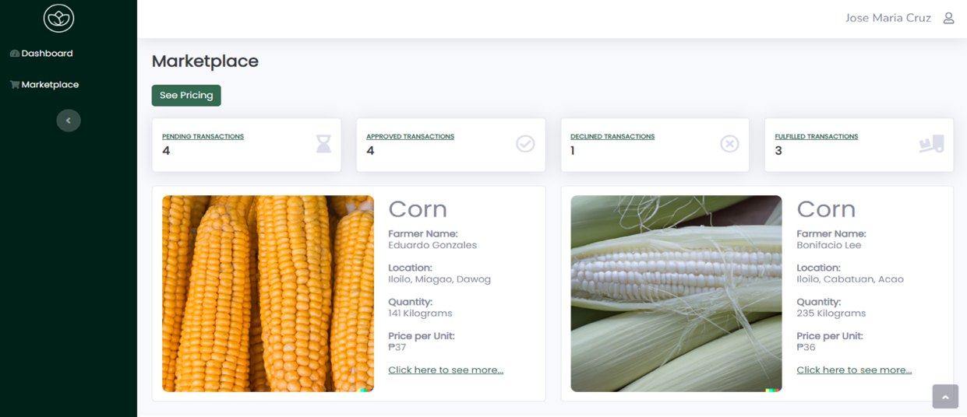

**Figure 16.** Marketplace Feature

Figure 16 shows the Marketplace Feature of the System. Showing the available resources and the farm location which will aid the business owners in selecting which farm to acquire their desired crop.

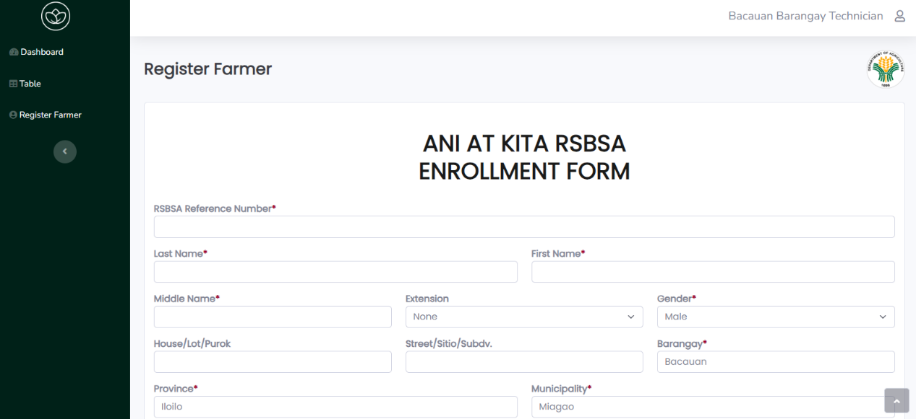

**Figure 17.** Register Farmer Feature

Figure 17 features a registration form based on the “Ani at Kita RSBSA Enrollment Form”.

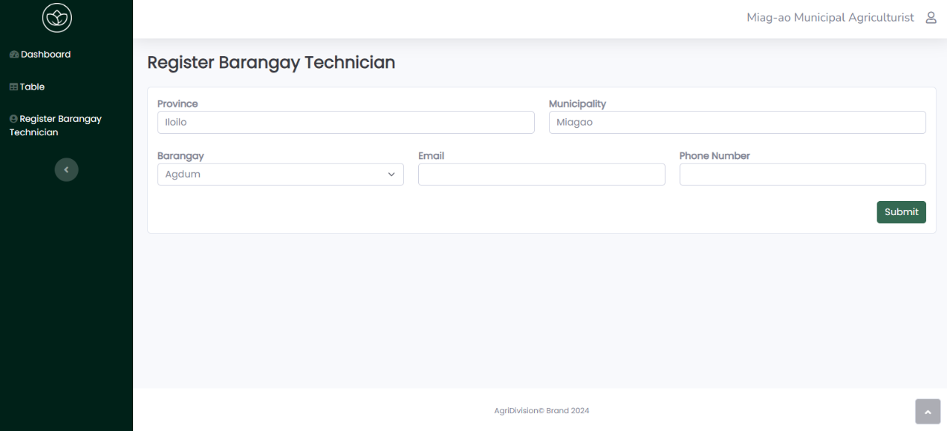

**Figure 18.** Register Barangay Technician

Figure 18 shows a feature on creating an account. The input should be the barangay technician’s personal information such as names, address, contacts, and other important information.

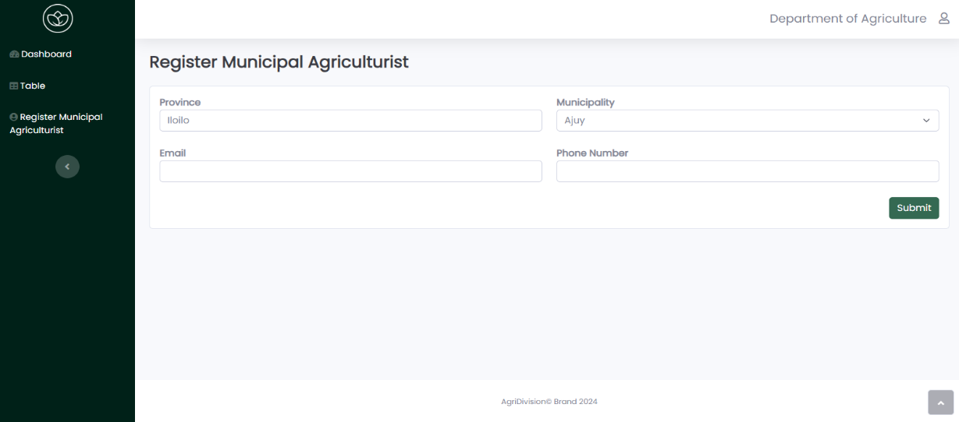

**Figure 19.** Register Municipal Agriculturist

Figure 19 shows a feature on creating an account. The input should be the Municipal Agriculturist’s personal information such as names, address, contacts, and other important information.

Results Interpretation and Analysis

The system was evaluated using the integrated survey questionnaire to target users including: (1) Barangay Technicians, (2) Municipal Agriculturists, (3) Business Owners, (4) Farmers. The questionnaires are distributed to five (5) evaluators and it is based on the ISO 25010 Software Quality Standards Form. It focuses on the traits and sub-traits that offer standardized language for defining and assessing the quality of software and system products. It also provides a set of quality characteristics against which stated quality requirements can be compared for completeness following aspects: (1) Functional Suitability, (2) Performance Efficiency, (3) Compatibility, (4) Usability, (5) Reliability, (6) Security, (7) Maintainability, and (8) Portability. The 4-point Likert Scale was utilized to determine the quality of the system: (1) Strongly disagree, (2) Disagree, (3) Agree, (4) Strongly Agree.

In terms of functional suitability, the system received a high rating of 4.80, indicating that it effectively meets the required functionality and performs its intended tasks very well, securing the top rank among the criteria. Reliability, with a rating of 4.55, also received a very good evaluation. This suggests that the system operates consistently and reliably, though it ranked fourth among the criteria. Usability and performance efficiency both received ratings of 4.40, indicating a very good level. However, the usability criterion received a rank of 7.5, suggesting that there may be some room for improvement in terms of user-friendliness and ease of use.

On the other hand, the performance efficiency criterion ranked slightly higher, at 6. Compatibility, with a rating of 4.40, shares the same score as usability and ranks 7.5. This implies that ensuring compatibility with other systems and environments could be an area for further attention. Security is another strong aspect of the system, as it received a rating of 4.53, placing it in fifth position among the criteria. This indicates that appropriate measures are in place to protect the system and user data. Maintainability and portability both received ratings of 4.60, indicating a very good level. However, they ranked lower in terms of priority, with a shared rank of 2.5. This suggests that while the system is relatively easy to maintain and transfer to different environments, it may not be the most critical aspect.

Overall, the system achieved a very good rating of 4.54. This indicates that it performs well across the evaluated criteria and is considered highly suitable for its intended purpose. In conclusion, the system demonstrates strong functional suitability, reliability, security, and overall performance. However, attention could be given to enhancing usability, performance efficiency, compatibility, maintainability, and portability to further improve the system's overall effectiveness and user experience.

System Evaluation Results

The system was presented to five evaluators which are municipal agriculturists, barangay technicians, farmers, and business owners respectively to test the system’s quality. The ISO/IEC 25010 is utilized in order to evaluate the system. The criteria is divided into eight parts:

1. Functional Suitability - to determine whether the system's functions fulfill their intended purposes.
2. Reliability - to verify the system’s stability and dependability.
3. Usability - to evaluate the system's user interface and overall user experience.
4. Performance Efficiency – to evaluate the system’s performance under different workloads and stress conditions.
5. Compatibility – to verify the system’s interoperability and adaptability.
6. Security - to identify potential weaknesses and vulnerabilities that could be exploited by attackers or unauthorized individuals.
7. Maintainability -  to evaluate the system’s manageability and supportability.
8. Portability - to evaluate the system’s adaptability and compatibility across different platforms, operating systems, and configurations.

Evaluation

As shown in Table 1, the evaluators have provided an average rating of 4.54, which corresponds to the classification of "Very Good." Based on their ratings, the evaluators found the system to be dependable, user-friendly, and comprehensible.

**Table 1**

System Evaluation Results of AgriDivision

|  |  |  |  |
| --- | --- | --- | --- |
| **Criteria** | **Mean** | **Description** | **Rank** |
| Functional Suitability | 4.80 | Very Good | 1 |
| Reliability | 4.55 | Very Good | 4 |
| Usability | 4.40 | Very Good | 7.5 |
| Performance Efficiency | 4.47 | Very Good | 6 |
| Compatibility | 4.40 | Very Good | 7.5 |
| Security | 4.53 | Very Good | 5 |
| Maintainability | 4.60 | Very Good | 2.5 |
| Portability | 4.60 | Very Good | 2.5 |
| **Overall Evaluation** | 4.54 | Very Good |  |

|  |  |
| --- | --- |
| **Scale** | **Description** |
| 5.20 – 6.00 | Excellent |
| 4.30 – 5.19 | Very Good |
| 3.50 – 4.29 | Good |
| 2.70 – 3.49 | Fair |
| 1.80 - 2.69 | Poor |
| 1.00 - 1.79 | Very Poor |

CHAPTER 5 SUMMARY, CONCLUSIONS, AND RECOMMENDATIONS

Summary of the Proposed System and Research Design

The researchers developed a system entitled “AgriDivision: Agricultural Mapping System with Demand Forecasting and Allocation” aimed to develop a web-based application for agricultural mapping systems, demand forecasting, and allocation for its user. The system is bound to project an output that would start from requiring the user to sign in or create an account based on what type of user they are assigned to (admin, farmer, municipal agriculturist, barangay technician, business owner), and input the information required. This web-based application used to determine the crops by forecasting the demand like Demand Forecasting Tool For Inventory Control Smart Systems but only focuses on local crop materials. This also uses mapping like Geographic Information System (GIS), Machine Learning technique in Demand Forecasting, and Optimization Algorithm. The system allocation is also related with 3D geological modelling based on 2D geological map which provides users shortest route for allocation of products wherein users can track the land/farm which produces the crops, and provides feedback on the accuracy of demand forecasting, the effectiveness of resource allocation, and the performance of farmers and business owners. The aforementioned are being used in order to fulfill the efficiency of the system.

The objectives of this study are; (1) to implement a platform wherein it forecasts the demand and allocates resources properly, (2) create a market in which users can see what resources are available, (3) establish a mapping system wherein it provide users the shortest route for allocation of products wherein users can track the land/farm which produces the crops, lastly, (4) provides feedback on the accuracy of demand forecasting, the effectiveness of resource allocation, and the performance of farmers and business owners.

The data of this study was gathered from a variety of sources such as the literature, archives, the internet, Department of Agriculture (DA) for the data of coffee and corn, Philippine Statistics Authority (PSA), and Philippine Coconut Authority (PCA) for the data of coconuts, and from their associated research studies.

The system utilized coding features like HTML, PHP, and JavaScript. Bootstrap was used to construct responsive websites by utilizing the Bootstrap framework. The coded features were assessed repeatedly to identify and correct any errors, in order to refine and optimize the system. The researchers recorded all identified bugs and errors, with the goal of producing a productive and efficient system that satisfies the end-users' requirements, and is ready for future implementation and submission of the required output. For the implementation of the system, six (6) parties are involved to use the system. The proponents will be the PCA and the DA. Meanwhile, the users will be Municipal Agriculturists, Barangay Technicians’, Farmers, and the Business Owners.

During the systems planning, the researchers have determined the purpose of the system and its importance for the general public, the intended audience, the individuals to be consulted, and the government entities to be visited. They have also identified the necessary requirements and tools that will be utilized for the creation of the system.

For the analysis of the systems, the researchers categorized the project objectives into specific functions, checking both the system and the amassed data. Researchers are also taking note of potential risks and problems that may arise and determining the most effective solutions to address them. On the other hand, the systems design is currently in the process of designing a system, which involves constructing its logical structure, interface, and database, as well as familiarizing themselves with the programming language to be employed. It will model the system on other existing systems or applications during this stage and develop it to ensure it is dependable, precise, and secure. The system will then be subjected to testing during the Systems Implementation phase, and made available to end-users.

The proposed system, which includes important stakeholders like the PCA (Philippine Coconut Authority) and the DA (Department of Agriculture), is an innovative agricultural management platform created to address the specific needs and challenges faced by farmers, business owners, and municipal agriculturists. Our approach seeks to improve production, promote sustainable farming methods, and expedite agricultural operations using the power of technology. Farmers will have access to an array of tools and services through a user-friendly interface to efficiently manage their crops, maintain track of their inventories, and get valuable market data.

Summary of Findings

The researchers developed a system entitled “AgriDivision: Agricultural Mapping System with Demand Forecasting and Allocation” aimed to create a web-based program for its users that would include demand forecasting, allocation, and agricultural mapping tools. Based on the user type they are assigned to (admin, farmer, municipal agriculturist, barangay technician, or business owner), the system will start by requesting the user to sign in or create an account and enter the necessary data.

The goals of this study are to implement a platform wherein it forecasts the demand and allocates resources properly. Then, it will create a market in which users can see what resources are available, this system also has a mapping system wherein it provides users the shortest route for allocation of products wherein users can track the land/farm which produces the crops, and provides feedback on the accuracy of demand forecasting, the effectiveness of resource allocation, and the performance of farmers and business owners.

The data gathered from several municipalities, farmers, barangay technicians, and business owners were utilized accordingly to create a comprehensive system that displays data according to what type of user is accessing the system.

After the testing and implementation of the system, it was then evaluated by five evaluators consisting of municipal agriculturists, farmers, barangay technicians, business owners.

Overall, the system received a rating of 4.54, indicating that it is “Very Good” based on the ISO 25010 Criteria. The system gained the highest rating in terms of Functional Suitability having 4.80, while the Usability, and Compatibility criteria ranked the lowest with 4.40.

Conclusions

The study "AgriDivision: Agricultural Mapping System with Demand Forecasting and Allocation" addresses the lack of an integrated platform for aggregating demand for raw crop materials, efficiently allocating resources, and providing a marketplace for agricultural products. Existing solutions are often fragmented, with separate systems for resource allocation, marketplace functionalities, and geographical mapping, leading to inefficiencies and data silos. Challenges include integrating these functionalities, ensuring data accuracy, and making the platform accessible and user-friendly, especially for smallholder farmers.

To overcome these challenges, the AgriDivision platform was developed, integrating multiple key features. It aggregates demand and allocates resources, provides a marketplace for transactions, and offers geographical visualization of crop data and mapping of key agricultural players. The platform also includes a demand forecasting module to aid in better planning and decision-making. The study found that AgriDivision successfully met its objectives, improving supply chain efficiency, accessibility, and resource management. The system's comprehensive approach and accurate data visualization demonstrated significant potential in enhancing agricultural operations and supporting the needs of various stakeholders in the sector.

Furthermore, the development of the web-based application in addressing the issue in crop monitoring, particularly in demand forecasting and allocation was accomplished accordingly. In addition, the centralized web-application helped the agencies of the Department of Agriculture and the Philippine Coconut Authority in improving the ins and outs of the product particularly for coconut, coffee, and corn.

Recommendations

After the development of the system, the users of the proposed system have given recommendations for the betterment of the system. The researchers should try to acquire actual data available from farmers, and business owners.

To extend the performance of the system, it is recommended to implement features for monitoring and tracking supply from farmers and demand from business owners, including real-time updates and alerts for any changes. Additionally, the system should allow business owners and farmers to set and view preferences, such as preferred suppliers, crop types, and quantity needs, providing more tailored information. Further enhancements could include analytics tools for tracking market trends, predictive analytics for future demand and supply trends, and mobile accessibility for on-the-go access. A feedback and rating system for transactions would also enhance trust and improve interactions. These features will make the platform more comprehensive and valuable for all users.

References

Agricultural Marketing : Agroprocessing. *(2008). https://agritech.tnau.ac.in/agricultural_marketing/agrimark_AgroProcessing.html*

Agroprocessing | CSIR. *(n.d.). https://www.csir.co.za/agroprocessing#:~:text=Agroprocessing%20refers%20to%20a%20subset%20of%20the%20manufacturing,demonstrate%20product%20and%20process%20capability%20at%20various%20scales*

Aguiar, A. S., dos Santos, F. N., Cunha, J. B., Sobreira, H., & Sousa, A. J. (2020). Localization and mapping for robots in agriculture and forestry: A survey. Robotics, 9(4), 97.

Allocation. (n.d.). Collins. https://www.collinsdictionary.com/dictionary/english/allocation#google_vignette

Aoki, H. (n.d). Development of drying technology utilizing solar energy to dry agricultural and marine products. CSDL |IEEE Computer Society. https://www.computer.org/csdl/proceedingsarticle/ecodim/2001/00992401/12OmNwO5LZu

Auhl, M. (2022). What is an ARIMA Model? - Towards Data Science.*Medium*. https://towardsdatascience.com/what-is-an-arima-model-9e200f06f9

Banton, C. (2023). Raw Materials: Definition, Accounting, and Direct vs. Indirect. *Investopedia*. https://www.investopedia.com/terms/r/rawmaterials.asp#:~:text=Raw%20materials%20are%20the%20input,gas%2C%20coal%2C%0and%20%20Minerals.

Chrismanto, A. R., Santoso, H. B., Wibowo, A., Delima, R., & Kristiawan, R. A. (2019). Developing agriculture land mapping using Rapid Application Development (RAD): A case study from Indonesia. International Journal of Advanced Computer Science and Applications, 10(10).

Christiansen, M. P., Laursen, M. S., Jørgensen, R. N., Skovsen, S., & Gislum, R. (2017). Designing and testing a UAV mapping system for agricultural field surveying. Sensors, 17(12), 2703.

Dacuycuy, C., Serafica, R. (2018). Harnessing the Potential of the Philippines’ Agricultural sector: An assessment using the product space. In *https://pidswebs.pids.gov.ph/CDN/PUBLICATIONS/pidsdps1816.pdf* (SERIES NO. 2018-16)

Debolin, M., Marraccini, E., Rizzo, D., Galli, M., Bonari, E. (2013). Mapping local spatial knowledge in the assessment of agricultural systems: A case study on the provision of agricultural services. Applied Geography. Volume 42. Pages 23-33

*Demand*.(2023).<https://dictionary.cambridge.org/dictionary/english/demand?q=DEMAND> [ALLOCATION | English meaning - Cambridge Dictionary](https://dictionary.cambridge.org/dictionary/english/allocation?q=ALLOCATION)

Department of Agriculture. (2023). DA Freedom of Information Manual. *What is a web-based system? | DSHS*. <https://www.dshs.wa.gov/faq/what-web-based-system>

Department of Agriculture. (2022). Facing the big challenges in Philippine Agriculture. *Official Portal of The Department of Agriculture.* https://www.da.gov.ph/faacing-the-big-challenges-in-philipine-agriculture/

Department: Trade, Industry and Competition. (2019). Chief Doctorate: Agro processing and Forestry Based Industries. http://www.thedtic.gov.za/sectors-and-services-2/industrial-development/agro-processing/#:~:text=Agro%2Dprocessing%20refers%20to%20the,fisheries%20and%20forestry%20based%20sectors.

Diezhandino, E. (2022). *Importance and Benefits*

*of Forecasting Customer Demand - Keepler | Cloud Data*

*Driven Partner*. Keepler | Cloud Data Driven Partner.

<https://keepler.io/2022/07/importance-and-benefits->of-forecasting-customer-demand/

Djekic, I., Batlle-Bayer, L., Bala, A., Fullana-I-Palmer, P., & Jambrak, A. R. (2021). Role of the Food Supply Chain Stakeholders in Achieving UN SDGs. *Sustainability*,*13*(16),9095.https://doi.org/10.3390/su13169095

Dumanski, J., Phipps, M. W., & Huffman, E. J. (1987). A Study of Relationships Between Soil Survey Data and Agricultural Land Use Using Information Theory. Canadian Journal of Soil Science, 67(1), 95–102. <https://doi.org/10.4141/cjss87-009>

Fonseka, D. D., & Karunasena, A. (2022). Comparison of ARIMA and LSTM in forecasting the retail prices of vegetables in Colombo, Sri Lanka. Comparison of ARIMA and LSTM in Forecasting the Retail Prices of Vegetables in Colombo, Sri Lanka. https://doi.org/10.1109/icac57685.2022.10025072

Gao, J. (2020). Research on the Network Marketing Model of Agricultural Products under the Background of "Internet +". CSDL | IEEE Computer Society. https://doi.org/10.1109/ecit50008.2020.00055

*GIS. Geographic Information System*(n.d.). https://education.nationalgeographic.org/resource/geographic-information-system-gis/

Hammonds, T. (2019). Use of GIS in Agriculture. Cornell Small Farms. https://smallfarms.cornell.edu/2017/04/use-of-gis/

Hand, R. (2023). *Demand Forecasting: How to* *Forecast Demand[+Examples]*.ShipBob.https://www.shipbob.com/blog/demand-forecasting/

Informer, E. (2023). Machine Learning in Demand

Forecasting (Applications & Best practices). *ERP Information*. <https://www.erp-information.com/machine-learning-in-demand-forecasting#:~:text=There%20are%20several%20different%20machine%20learning%20algorithms%20that,and%20deep%20learning%20for%20more%20complex%20forecasting%20tasks>

International Food Policy Research Institute (2017). Agro-MAPS (Mapping of Agricultural Production Systems) Retrieved on November 28, 2022 from, <https://www.ifpri.org/publication/agro-maps-mapping-agricultural-production-systems>

Inventory.(2023).https://dictionary.cambridge.org/dictionary/english/inventory?q=INVENTORY

Kruska, R. L., Reid, R. S., Thornton, P. K., Henninger, N., & Kristjanson, P. M. (2003).Mapping livestock-oriented agricultural production systems for the developing world. Agricultural systems, 77(1), 39-63.

Manish, R., Lin, Y. C., Ravi, R., Hasheminasab, S. M., Zhou, T., & Habib, A. (2021).Development of a miniaturized mobile mapping system for in-row, under-canopy phenotyping. Remote Sensing, 13(2), 276.

Mapbox GL JS. (n.d.). Draw a polygon and calculate its area Draw a polygon and calculate its area Mapbox. <https://docs.mapbox.com/mapbox-gl-js/example/mapbox-gl-draw/>

Marsujitullah, M., Fransiskus, X. M., Darsono, T. A., & Latif, A. (2021). Geographical Information System for Mapping and Analysis of Agricultural Areas in Merauke Regency. Geographical Information System for Mapping and Analysis of Agricultural Areas in Merauke Regency. In E3S Web of Conferences (Vol. 328, p. 03004). EDP Sciences.

McKinsey & Company. (2022). *What is supply chain?* (2022). <https://www.mckinsey.com/featured-insights/mckinsey-explainers/what-is-supply-chain>

Micro, Small and Medium Enterprises. (n.d.). International Labour Organization. https://www.ilo.org/topics/micro-small-and-medium-enterprises

Petropoulos, F., Apiletti, D., Assimakopoulos, V., Babai, M. Z., Barrow, D. K., Taieb, S. B., Bergmeir, C., Bessa, R. J., Bijak, J., Boylan, J. E., Browell, J., Carnevale, C., Castle, J. L., Cirillo, P., Clements, M. P., Cordeiro, C., Oliveira, F. R., De Baets, S., Dokumentov, A., . . . Ziel, F. (2022). Forecasting: theory and practice. International Journal of Forecasting, 38(3), 705–871. <https://doi.org/10.1016/j.ijforecast.2021.11.001>

*Understanding LSTM Networks -- colah’s blog*. (n.d.). <https://colah.github.io/posts/2015-08-Understanding-LSTMs/>

*What is MSME? Meaning, Full Form, Features, Role & Importance in India*. (n.d.). Lendingkart. [https://www.lendingkart.com/msme-loan/what-is-msme/*forecasting*.(2023).https://dictionary.cambridge.org/dictionary/english/forecasting](https://www.lendingkart.com/msme-loan/what-is-msme/forecasting.(2023).https://dictionary.cambridge.org/dictionary/english/forecasting)

Yang, A. (2021). Empowering Filipino farmers through organicagriculture.OneEarth.https://www.oneearth.org/empowering-filipino-farmers-through-organic-agriculture/

You, L., Wood, S., & Wood-Sichra, U. (2009). Generating plausible crop distribution maps for Sub-Saharan Africa using a spatially disaggregated data fusion and optimization approach. *Agricultural Systems*, *99*(2–3), 126–140. <https://doi.org/10.1016/j.agsy.2008.11.003>

Appendices

Appendix A

Letter of Request to the Adviser

Appendix B

Letter of Request to the Editor







Appendix C

Letter to Conduct Interview

March 13, 2023

Engr. Jose Albert A. Barrogo

Director III

OIC. Regional Executive Director

Department of Agriculture, RF06, Iloilo City

Dear Engr. Barrogo,

In partial fulfillment of our requirements for our course Thesis Writing for IS 1, we the 3rd year Bachelor of Science in Information Systems students of West Visayas State University namely: Andrea Joane Agustin, Bryan Kyle Fantilaga, Charles Agustin Monreal, Adrianne Blu Sanchez, and Royce Emmanuel Trinidad would like to conduct a research study entitled “AgriDivision(Agricultural Mapping System with Demand Forecasting and Allocation)”

In line with this, we would like to request your department’s permission to gather data of raw crop materials, specifically corn and coffee. Rest assured that the data we will gather will remain absolutely confidential and to be used for academic purposes only.

We hope for your positive response on this humble matter. Your approval to conduct this study will be greatly appreciated.

Respectfully yours,

Andrea Joane Agustin

Bryan Kyle Fantilaga

Charles Agustin Monreal

Adrianne Blu Sanchez

Royce Emmanuel Trinidad

Noted by:

SHEM DURST ELIJAH B. SANDIG, MSIT

Research Adviser

Recommending Approval:

DR. MA. BETH CONCEPCION

Dean, College of ICT

Approved by:

ENGR. JOSE ALBERT A. BARROGO

Director III

OIC. Regional Executive Director, Department of Agriculture, RF06, Iloilo City

May 12, 2023

NELIDA C. AMOLAR

Chief Statistical Specialist

Officer-in-Charge

PSA RSSO VI

Dear Ma’am Amolar,

In partial fulfillment of our requirements for our course Thesis Writing for IS 1, we the 3rd year Bachelor of Science in Information Systems students of West Visayas State University namely: Andrea Joane Agustin, Bryan Kyle Fantilaga, Charles Agustin Monreal, Adrianne Blu Sanchez, and Royce Emmanuel Trinidad would like to conduct a research study entitled “AgriDivision(Agricultural Mapping System with Demand Forecasting and Allocation)”.

In line with this, we would like to request your department’s permission to gather data of raw crop materials, specifically corn and coffee. Rest assured that the data we will gather will remain absolutely confidential and to be used for academic purposes only.

We hope for your positive response on this humble matter. Your approval to conduct this study will be greatly appreciated.

Respectfully yours,

Andrea Joane Agustin

Bryan Kyle Fantilaga

Charles Agustin Monreal

Adrianne Blu Sanchez

Royce Emmanuel Trinidad

Noted by:

SHEM DURST ELIJAH B. SANDIG, MSIT

Research Adviser

Recommending Approval:

DR. MA. BETH CONCEPCION

Dean, College of ICT

Approved by:

NELIDA C. AMOLAR

Chief Statistical Specialist, Officer-in-Charge, PSA RSSO VI

April 3, 2023

MR. JOEL P. SOLIS

Division Chief II

Philippine Coconut Authority

Inangayan, Sta. Barbara, Iloilo

Dear Mr. Solis,

In partial fulfillment of our requirements for our course Thesis Writing for IS 1, we the 3rd year Bachelor of Science in Information Systems students of West Visayas State University namely: Andrea Joane Agustin, Bryan Kyle Fantilaga, Charles Agustin Monreal, Adrianne Blu Sanchez, and Royce Emmanuel Trinidad would like to conduct a research study entitled “AgriDivision(Agricultural Mapping System with Demand Forecasting and Allocation)”.

In line with this, we would like to request your department’s permission to gather data of raw crop materials, specifically corn and coffee. Rest assured that the data we will gather will remain absolutely confidential and to be used for academic purposes only.

We hope for your positive response on this humble matter. Your approval to conduct this study will be greatly appreciated.

Respectfully yours,

Andrea Joane Agustin

Bryan Kyle Fantilaga

Charles Agustin Monreal

Adrianne Blu Sanchez

Royce Emmanuel Trinidad

Noted by:

SHEM DURST ELIJAH B. SANDIG, MSIT

Research Adviser

Recommending Approval:

DR. MA. BETH CONCEPCION

Dean, College of ICT

Approved by:

JOEL P. SOLIS

Division Chief II, Philippine Coconut Authority, Sta. Barbara Iloio

Appendix D

Gantt Chart

Appendix E

Data Dictionary

Admin Table

|  |  |  |  |  |
| --- | --- | --- | --- | --- |
| Field Type | Data Type | Field Size | Description | Example |
| id | int | 11 | Admin Table Primary Key | 123 |
| admin_id | varchar | 100 | Admin ID | DA1 |
| name | varchar | 100 | Admin Name | John |
| email | varchar | 100 | Admin Email | john@gmail.com |
| phone_number | varchar | 100 | Admin Phone Number | 09561895614 |
| province | varchar | 100 | Admin Province | Iloilo |
| password | varchar | 100 | Admin Password | Miagao |
| regdate | date |  | Admin Registration Date | 12/21/2023 |

Barangay Technician

|  |  |  |  |  |
| --- | --- | --- | --- | --- |
| Field Type | Data Type | Field Size | Description | Example |
| id | int | 11 | Brgy Tech Table Primary Key | 123 |
| brgy_tech_id | varchar | 100 | Barangay Technician ID | BT1 |
| municipal_id | varchar | 100 | Barangay Technician Municipal ID | MA1 |
| name | varchar | 100 | Barangay Technician Name | John Doe |
| province | int | 100 | Barangay Technician Province | Iloilo |
| municipality | varchar | 100 | Barangay Technician Municipality | Miagao |
| barangay | varchar | 100 | Barangay Technician Barangay | Baybay Sur |
| email | varchar | 100 | Barangay Technician Email | johndoe@gmail.com |
| phone | varchar | 100 | Barangay Technician Phone | 09123456789 |
| password | varchar | 100 | Barangay Technician Password | JohnDoe01 |
| regdate | date |  | Barangay Technician Registration date | 12/21/2023 |

Business Owner Table

|  |  |  |  |  |
| --- | --- | --- | --- | --- |
| Field Type | Data Type | Field Size | Description | Example |
| id | int | 100 | Business Owner Primary Key | 123 |
| business_id | varchar | 100 | Business Owner ID | B01 |
| business_fname | varchar | 100 | Business Owner First Name | John |
| business_mname | varchar | 100 | Business Owner Middle Name | Michael |
| business_lname | varchar | 100 | Business Owner Last Name | Doe |
| business_gender | varchar | 100 | Business Owner Gender | Male |
| business_email | varchar | 100 | Business Owner Email | johndoe@gmail.com |
| business_phone | varchar | 100 | Business Owner Phone Number | 09123456789 |
| business_permit | varchar | 100 | Business Owner Permit | BP-2021-0000X-0 |
| business_province | varchar | 100 | Business Owner Province | Iloilo |
| business_minicipality | varchar | 100 | Business Owner Municipality | Miagao |
| business_barangay | varchar | 100 | Business Owner Barangay | Baybay Sur |
| business_street | varchar | 100 | Business Owner Street | Hinolan Street |
| business_dob | date |  | Business Owner Date of Birth | 12/21/2023 |
| business_latitude | float |  | Business Owner Latitude | 10° 38' 26.4 |
| business_longitude | float |  | Business Owner Longtitude | 122°14'6.3 |
| commodity_id | varchar | 100 | Business Owner Commodity ID | CM1 |
| commodity_name | varchar | 100 | Business Owner Commodity Name | Corn |
| password | varchar | 100 | Business Owner Password | JohnDoe01 |
| date | date |  | Business Owner Registration Date | 12/21/2023 |

Commodity Name Table

|  |  |  |  |  |
| --- | --- | --- | --- | --- |
| Field Type | Data Type | Field Size | Description | Example |
| id | int | 11 | Commodity Primary Key | 123 |
| commodity_id | varchar | 100 | Commodity ID | CM1 |
| commodity_name | varchar | 100 | Commodity Name | Corn |
| commidity_variant | varchar | 100 | Commodity Variant | Dent |
| commodity_metric | varchar | 100 | Commodity Metric | 90 Kg |
| pricing | float |  | Commodity Product Pricing | P50 |

Farm Table

|  |  |  |  |  |
| --- | --- | --- | --- | --- |
| Field Type | Data Type | Field Size | Description | Example |
| id | int | 11 | Farm Table Primary Key | 123 |
| farm_id | varchar | 100 | Farm ID | F1 |
| farmer_id | varchar | 100 | Farm Farmer ID | FM1 |
| farm_area | float |  | Farm Land Size | 100 Hectares |
| ancestral_domain | varchar | 100 | Farm Ancestral Domain | Yes |
| farm_document_no | varchar | 100 | Farm Documentation Number | 40214.00 |
| agrarian_beneficiary | varchar | 100 | Farm Agrarian Beneficiary | 2023-12-07 |
| ownership_type | varchar | 100 | Farm Ownership Type | Tenant |
| commidity_id | varchar | 100 | Farm Commodity ID | CM1 |
| commodity_name | varchar | 100 | Farm Commodity Name | Corn |
| farm_type | varchar | 100 | Farm Type | Irrigated |

Farmer Data Table

|  |  |  |  |  |
| --- | --- | --- | --- | --- |
| Field Type | Data Type | Field Size | Description | Example |
| id | int | 11 | Farmer Primary Key | 123 |
| farmer_id | varchar | 100 | Farmer_ID | FM1 |
| brgy_tech_id | varchar | 100 | Farmer Barangay Tech ID | BT1 |
| rsbsanum | varchar | 100 | Farmer RSBSA Number | 12345678 |
| lname | varchar | 100 | Farmer Last Name | Doe |
| fname | varchar | 100 | Farmer First Name | John |
| mname | varchar | 100 | Farmer Middle Name | Micheal |
| extension | varchar | 100 | Farmer Extensions | Jr |
| gender | varchar | 100 | Farmer Gender | Male |
| house | varchar | 100 | Farmer House Number | 123 |
| street |  | 100 | Farmer Street | Hinolan Street |
| barangay | varchar | 100 | Farmer Barangay | Baybay Sur |
| province | varchar | 100 | Farmer Province | Iloilo |
| municipality | varchar | 100 | Farmer Municipality | Miagao |
| latitude | float |  | Farmer Latitude | Miagao |
| longitude | float |  | Farmer Longitude | 10° 38' 26.4 |
| phone | varchar | 100 | Farmer Phone Number | 122°14'6.3 |
| email | varchar | 100 | Farmer Email | johndoe@gmail.com |
| dob | date |  | Farmer Date Of Birth | 12/21/2023 |
| religion | varchar | 100 | Farmer Religion | Catholic |
| civil_status | varchar | 100 | Farmer Civil Status | Single |
| mother_lname | varchar | 100 | Farmer Mother Last Name | Doe |
| mother_fname | varchar | 100 | Farmer Mother First Name | Jonna |
| mother_mname | varchar | 100 | Farmer Mother Middle Name | Mitchel |
| household_head | varchar | 100 | Farmer Household Head | Yes |
| household_head_name | varchar | 100 | Farmer Household Head Name | John |
| relationship | varchar | 100 | Farmer Relationship | Son |
| household_members | varchar | 100 | Farmer Household Members | 6 |
| household_male | varchar | 100 | Farmer Household Male | 3 |
| household_female | varchar | 100 | Farmer Household Female | 3 |
| education | varchar | 100 | Farmer Education | Elementary |
| disability | varchar | 100 | Farmer Disability | No |
| beneficiary | varchar | 100 | Farmer Beneficiary | No |
| indigenous | varchar | 100 | Farmer Indigenous | No |
| indigenous_group | varchar | 100 | Farmer Indigenous Group | No |
| government_id | varchar | 100 | Farmer Government ID | Yes |
| id_type | varchar | 100 | Farmer ID Type | National ID |
| id_number | varchar | 100 | Farmer Id Number | 6154-7645-6543-0979 |
| faremrer_associate | varchar | 100 | Farmer Associate | Yes |
| association_name | varchar | 100 | Farmer Associate Name | John |
| contact_person | varchar | 100 | Farmer Contact Person | Jonna |
| contact_person_phone | varchar | 100 | Farmer Contact Person Phone Number | 09123456789 |
| password | varchar | 100 | Farmer Password | johndoe01 |
| livelihood | varchar | 100 | Farmer Livelihood | Farmer |
| regdate | date |  | Farmer Registration Date | 12/21/2023 |

Market Data Table

|  |  |  |  |  |
| --- | --- | --- | --- | --- |
| Field Type | Data Type | Field Size | Description | Example |
| id | int | 11 | Market Data Primary Key | 123 |
| market_id | varchar | 100 | Market ID | M1 |
| farmer_id | varchar | 100 | Market Farmer Id | FM1 |
| farmer_fname | varchar | 100 | Market Farmer First Name | John |
| farmer_lname | varchar | 100 | Market Farmer Last Name | Doe |
| farmer_province | varchar | 100 | Market Farmer Province | Iloilo |
| farmer_municipality | varchar | 100 | Market Farmer Municipality | Miagao |
| farmer_barangay | varchar | 100 | Market Farmer Barangay | Baybay Sur |
| farmer_lat | varchar | 100 | Market Farmer Latitude | 10° 38' 26.4 |
| farmer_long | varchar | 100 | Market Farmer Longitude | 122°14'6.3 |
| commodity_id | varchar | 100 | Market Commodity ID | CM1 |
| commodity_name | varchar | 100 | Market Commodity Name | Corn |
| commodity_price | floar |  | Market Commodity Price | P50 |
| commodity_quantity | float |  | Market Commodity Quantity | 100 |
| phone_number | varchar | 100 | Market Phone Number | 09123456789 |
| description | varchar | 100 | Market Description | Corn |
| image_name | varchar | 100 | Market Image Name | Corn.jpeg |
| date | date |  | Upload Date | 12/21/2023 |

Municipal Agriculturist Data Table

|  |  |  |  |  |
| --- | --- | --- | --- | --- |
| Field Type | Data Type | Field Size | Description | Example |
| id | int | 11 | Agriculturist Primary Key | 123 |
| municipal_id | varchar | 100 | Agriculturist Municipal ID | MA1 |
| admin_id | varchar | 100 | Agriculturist Admin Id | DA1 |
| name | varchar | 100 | Agriculturist Name | John Doe |
| province | varchar | 100 | Agriculturist Province | Iloilo |
| municipality | varchar | 100 | Agriculturist Municipality | Miagao |
| email | varchar | 100 | Agriculturist Email | johndoe@gmail.com |
| phone | varchar | 100 | Agriculturist Phone | 09123456789 |
| password | varchar | 100 | Agriculturist Password | johndoe01 |
| regdate | date |  | Agriculturist Registration Date | 12/21/2023 |

Production Data Table

|  |  |  |  |  |
| --- | --- | --- | --- | --- |
| Field Type | Data Type | Field Size | Description | Example |
| id | int | 11 | Production Data Table Primary Key | 123 |
| production_id | varchar | 100 | Production ID | P1 |
| farmer_id | varchar | 100 | Production Farmer ID | FM1 |
| commodity_id | varchar | 100 | Production Commodity ID | CM1 |
| commodity_name | varchar | 100 | Production Commodity Name | Corn |
| amount | float |  | Production Amount | 100 |

Total Production Table

|  |  |  |  |  |
| --- | --- | --- | --- | --- |
| Field Type | Data Type | Field Size | Description | Example |
| id | int | 11 | Total Production Data Table Primary Key | 123 |
| production_id | varchar | 100 | Production ID | P1 |
| farmer_id | varchar | 100 | Production Farmer ID | FM1 |
| commodity_id | varchar | 100 | Production Commodity ID | CM1 |
| commodity_name | varchar | 100 | Production Commodity Name | Corn |
| amount | float |  | Production Amount | 100 |
| date | date |  | Upload Date | 12/21/2023 |

Sales Data Table

|  |  |  |  |  |
| --- | --- | --- | --- | --- |
| Field Type | Data Type | Field Size | Description | Example |
| id | int | 11 | Sales Table Primary Key | 123 |
| sales_id | varchar | 100 | Sales ID | S1 |
| farmer_id | varchar | 100 | Sales Farmer ID | FM1 |
| commodity_id | varchar | 100 | Sales Commodity ID | CM1 |
| commodity_name | varchar | 100 | Sales Commodity Name | Corn |
| amount | float |  | Sales Amount | P50 |
| date | date |  | Sales Date | 12/21/2023 |

Appendix F

Entity-Relationship Diagram

**

Appendix G

Sample Program Codes

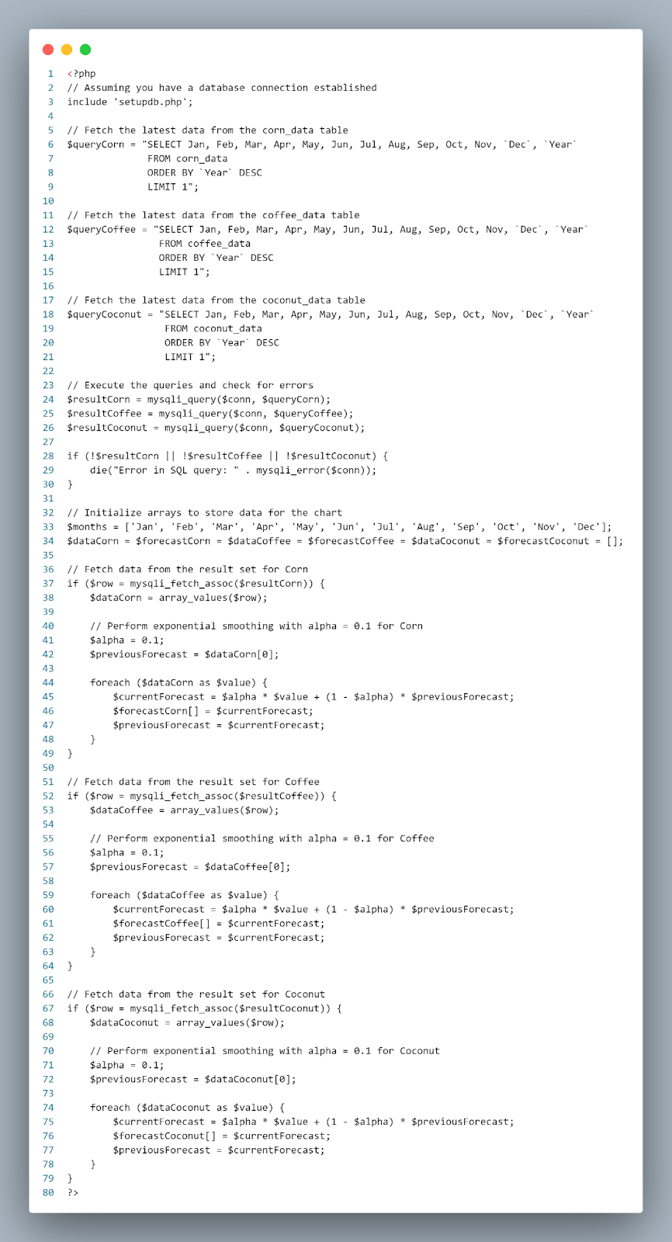

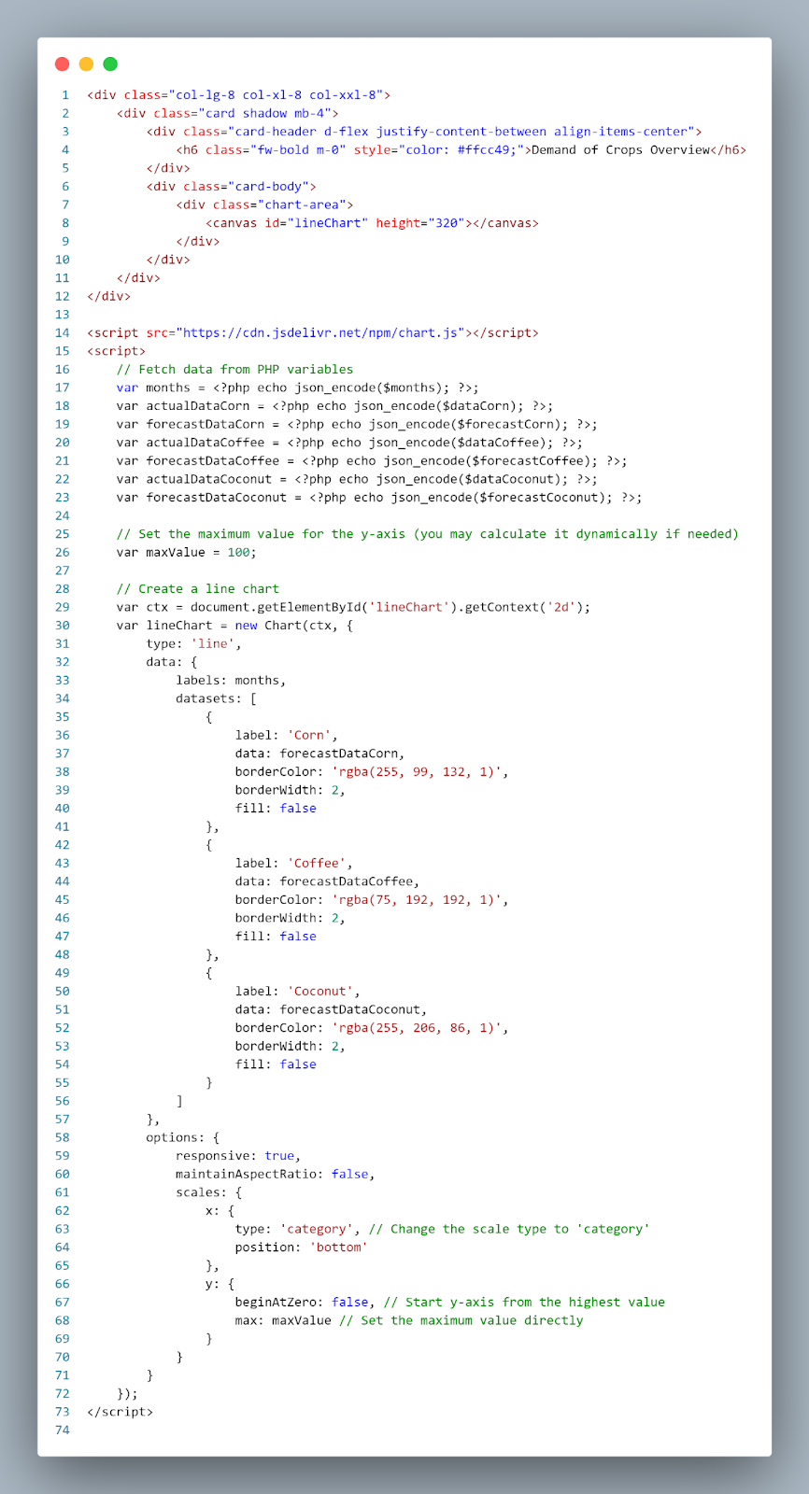

Appendix H

ISO 25010 Software Quality Standards Form

**ISO 25010 Software Quality Evaluation Instrument**

System Evaluation Sheet for “AgriDivison: Agricultural Mapping System with Demand Forecasting and Allocation”

Name of Evaluator: ___________________________________

(Business Owner/ Farmer/ Municipal Agriculturist/ Barangay Technician/Admin)

Scale                                Description

5.20 – 6.00                          Excellent

4.30 – 5.19                          Very Good

3.50 – 4.29                          Good

2.70 – 3.49                          Fair

1.80 - 2.69                           Poor

1.00 - 1.79                           Very Poor

**Evaluation Proper**

|  |  |  |  |
| --- | --- | --- | --- |
| **Characteristic** | **Sub- Characteristics** | **Description** | **Evaluation Rating** |
| **Functional Suitability** | Functional  completeness | Degree to which the set of functions covers all the specified tasks and  user objectives. |  |
| Functional  correctness | Degree to which a product or system provides the correct results with the  needed degree |  |
| Functional  appropriateness | Degree to which the functions facilitate the  accomplishment of specified tasks and  objectives. |  |
| **Performance Efficiency** | Time behavior | Degree to which the response and processing  times and throughout rates of a product or  system, when performing its functions, meet  requirements. |  |
| Resource  utilization | Degree to which the amounts and types of  resources used by a product or system, when  performing its functions, meet requirements. |  |
| Capacity | Degree to which the maximum limits of a  product or system parameter meet requirements. |  |
| **Compatibility** | Co-existence | Degree to which a product can perform its required functions efficiently while sharing a common environment and resources with other products, without detrimental impact on any other product. |  |
| Interoperability | Degree to which two or more systems, products or components can exchange information and use the information that has been exchanged. |  |
| **Usability** | Appropriateness  recognizability | Degree to which users can recognize whether a product or system is appropriate for their needs. |  |
| Learnability | Degree to which a product or system can be used by specified users to achieve specified goals of learning to use the product or system with effectiveness, efficiency, freedom from risk and satisfaction in a specified context of use. |  |
| Operability | Degree to which a product or system has attributes that make it easy to operate and control. |  |
| User error  protection | Degree to which a system protects users against making errors. |  |
| User  interface  aesthetics | Degree to which a user interface enables pleasing and satisfying interaction for the user. |  |
| Accessibility | Degree to which a product or system can be used by people with the widest range of characteristics and capabilities to achieve a specified goal in a specified context of use. |  |
| **Reliability** | Maturity | Degree to which a system, product or component meets needs for reliability under normal operation. |  |
| Availability | Degree to which a system, product or component is operational and accessible when required for use. |  |
| Fault  tolerance | Degree to which a system, product or component operates as intended despite the presence of hardware or software faults. |  |
| Recoverability | Degree to which, in the event of an interruption or a failure, a product or system can recover the data directly affected and re-establish the desired state of the system. |  |
| **Security** | Confidentiality | Degree to which a product or system ensures that data are accessible only to those authorized to  have access. |  |
| Integrity | Degree to which a system, product or component prevents unauthorized access to, or modification of, computer programs or data. |  |
| Non-repudiation | Degree to which actions or events can be proven to have taken place so that the events or actions cannot be repudiated later. |  |
| Accountability | Degree to which the actions of an entity can be traced uniquely to the entity. |  |
| Authenticity | Degree to which the identity of a subject or resource can be proved to be the one claimed. |  |
| **Maintainability** | Modularity | Degree to which a system or computer program is composed of discrete components such that a change to one component has minimal impact on other components. |  |
| Reusability | Degree to which an asset can be used in more than one system, or in building other assets. |  |
| Analyzability | Degree of effectiveness and efficiency with which it is possible to assess the impact on a product or system of an intended change to one or more of its parts, or to diagnose  a product for deficiencies or causes of failures, or to identify parts to be modified. |  |
| Modifiability | Degree to which a product or system can be effectively and efficiently modified without introducing defects or degrading existing product quality. |  |
| Testability | Degree of effectiveness and efficiency with which test criteria can be established for a system, product or component and tests can be performed to determine whether those criteria have been met. |  |
| **Portability** | Adaptability | Degree to which a product or system can effectively and efficiently be adapted for different or evolving hardware, software or other operational or usage environments. |  |
| Installability | Degree of effectiveness and efficiency with which a product or system can be successfully installed and/or uninstalled in a  specified environment. |  |
| Replaceability | Degree to which a product can replace another specified software product for the same purpose in the same environment. |  |

Appendix J

Disclaimer

This software project and its corresponding documentation  entitled “AgriDivision: Agricultural Mapping System with Demand Forecasting and Allocation” is submitted to the College of Information and Communications Technology, West Visayas State University, in partial fulfillment of the requirements for the degree, Bachelor of Science in Information Systems. It is the product of our own work, except where indicated text.

We hereby grant the College of Information and Communications Technology permission to freely use, publish in local or international journal/conferences, reproduce, or distribute publicly the paper and electronic copies of this software project and its corresponding documentation in whole or in part, provided that we are acknowledged.

Andrea Joane J. Agustin Adrianne Blu T. Sanchez

Bryan Kyle E. Fantilaga Royce Emmanuel A. Trinidad

Charles Agustin C. Monreal

June 2024